ILLENIUM DROPS STAR-STUDDED FIFTH ALBUM
WITH COLLABORATIONS FROM AVRIL LAVIGNE, TRAVIS BARKER, ALL TIME LOW, JVKE, JXDN, TEDDY SWIMS AND MORE

LISTEN TO ILLENIUM HERE

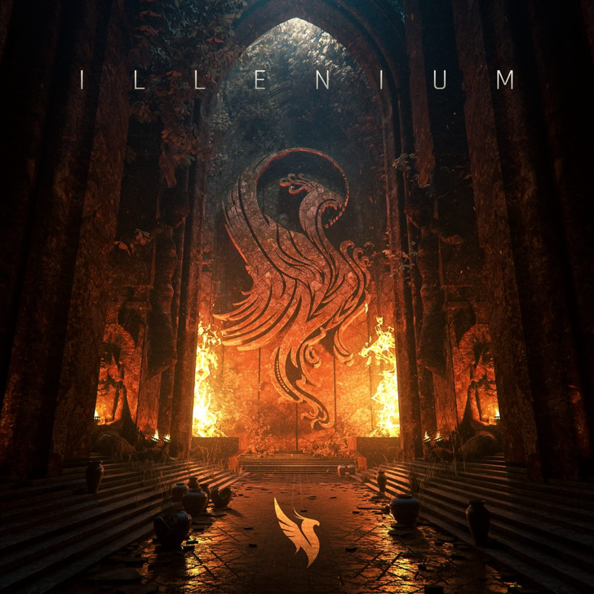
Download hi-res artwork HERE

April 28, 2023 (Los Angeles, CA) – Today, Grammy-nominated producer ILLENIUM shares his fifth studio album, a star-studded self-titled collection full of heart, soul, and cinematic beauty. Listen HERE via Warner Records. The 16-track set includes the #1 dance hits “All That Really Matters” with Teddy Swims and “Luv Me A Little” with Nina Nesbitt. And that’s just the tip of the iceberg as he invites Avril Lavigne, Travis Barker, Vera Blue, All Time Low, JVKE, and more to kick things into even higher gear.

On ILLENIUM, the multi-talented artist shows off his impressive versatility, building sweeping soundscapes that bring out the best in each of his collaborators—no matter the genre. “Making this album, I found so much joy exploring the sounds that have given me lifelong inspiration,” ILLENIUM says. “I feel like I’ve found an ideal balance between electronic and rock music that’s genuine and unique.

Throughout the album, he leans into a harder sound, joining forces with pop-punk royalty Avril Lavigne and Travis Barker on the propulsive “Eyes Wide Shut” before jumping on board with alt-metal band Spiritbox for the dubstep-fueled “Shivering” and later with metalcore heroes Motionless In White for the industrial-tinged “Nothing Ever After.” After 15 tracks heavy in sound and emotion, he closes it all out on a slightly softer note with Nina Nesbitt on the hopeful “Luv Me a Little.”

“The music, and a whole new live show, should be unlike anything anyone has ever seen or heard before,” ILLENIUM promises. With the album finally dropping, he is ready to bring it all to the stage with his upcoming ILLENIUM LIVE tour throughout North America, Europe, and Australia. One stop along the way will be the biggest show of his career: Trilogy: Colorado, at Empower Field at Mile High in Denver, CO on Saturday, June 17, 2023. There, he will be performing three unique sets over one night. Tickets for all dates are on sale HERE. For the tour, he will also be partnering with the non-profit End Overdose, an organization close to his heart.

ILLENIUM Tracklist:

1. “Starfall”
2. “All That Really Matters” (with Teddy Swims)
3. “Worst Day” (with MAX)
4. “From the Ashes” (with Skylar Grey)
5. “Lifeline” (with jxdn)
6. “Eyes Wide Shut” (with Avril Lavigne and Travis Barker)
7. “Shivering” (with Spiritbox)
8. “You Were Right” (with Wooli & Grabbitz)
9. “Insanity” (with American Teeth)
10. “Drwn”
11. “Other Side” (with Said The Sky & Vera Blue)
12. “I Want U 2 (Stay)”
13. “With All My Heart” (with JVKE)
14. “Back To You” (with All Time Low)
15. “Nothing Ever After” (with Motionless In White)
16. “Luv Me A Little” (with Nina Nesbitt)

ILLENIUM LIVE 2023 TOUR DATES

NORTH AMERICA
May 27 – George, WA @ The Gorge
May 28 – George, WA @ The Gorge
Jun 2 – San Francisco, CA @ Chase Center
Jun 3 – San Francisco, CA @ Chase Center
Jun 4 – Lake Tahoe, NV @ Lake Tahoe Outdoor Areana at Harveys
Jun 8 – Bonner Springs, KS @ Azura Amphitheater
Jun 9 – Minneapolis, MN @ The Armory
Jun 10 – Minneapolis, MN @ The Armory
Jun 11 – Minneapolis, MN @ The Armory
Jun 17 – Denver, CO @ Empower Field at Mile High
Jun 20 – Cleveland, OH @ Jacobs Pavilion
Jun 21 – Newport, KY @ MegaCorp Pavilion Outdoor
Jun 23 – Rothbury, MI @ Electric Forest
Jun 27 – St. Louis, MO @ The Factory
Jun 28 – Huntsville, AL @ The Orion Amphitheater
Jun 30 – Austin, TX @ Moody Center
Jul 1 – Dallas, TX @ Dos Equis Pavilion
Jul 2 – Houston, TX @ 713 Music Hall
Jul 7 – Atlanta, GA @ Lakewood Amphitheatre
Jul 8 – Orlando, FL @ Orlando Amphitheater
Jul 13 – Pittsburgh, PA @ Stage AE Outdoors
Jul 14 – Brooklyn, NY @ Barclays Center
Jul 15 – Columbia, MD @ Merriweather Post Pavilion
Jul 20 – Indianapolis, IN @ TCU Amphitheater at White River State Park
Jul 21 – Detroit, MI @ Masonic Temple Theatre
Jul 22 – Bridgeview, IL @ SeatGeek Stadium
Aug 4 – Toronto, ON @ Veld Music Festival

EUROPE
Oct 11 – Barcelona, Spain @ Razzmatazz
Oct 13 – Milan, Italy @ Fabrique
Oct 14 – Warsaw, Poland @ Progresja
Oct 18 – Paris, France @ Elysée Montmartre
Oct 20 – Amsterdam, Netherlands @ MELKWEG
Oct 21 – Brussels, Belgium @ La Madeleine
Oct 26 – London, England @ Electric Brixton
Oct 27 – London, England @ Electric Brixton

AUSTRALIA
Nov 25 – Sydney, Australia @ Hordern Pavillion
Dec 1 – Melbourne, Australia @ John Cain Arena
Dec 2 – Brisbane, Australia @ The Fortitude Music Hall

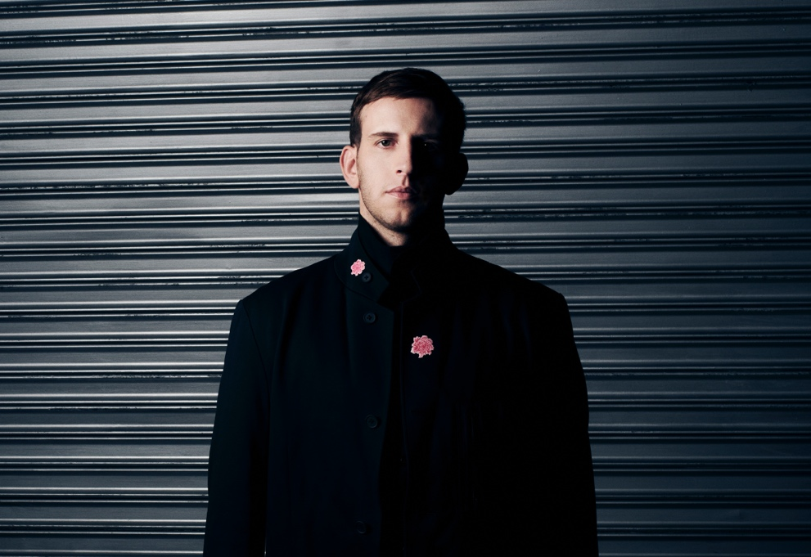
Credit: Lindsey Byrnes | Hi-Res Download HERE

FOLLOW ILLENIUM:
Website | Twitter | Instagram | Facebook | YouTube

For more information, please contact:
Darren Baber | Darren.Baber@warnerrecords.com

