VOCAL POWERHOUSE TEDDY SWIMS ANNOUNCES
FALL 2023 I’VE TRIED EVERYTHING BUT THERAPY NORTH AMERICAN TOUR

TICKETS ON SALE FRIDAY, JUNE 9th
AVAILABLE HERE

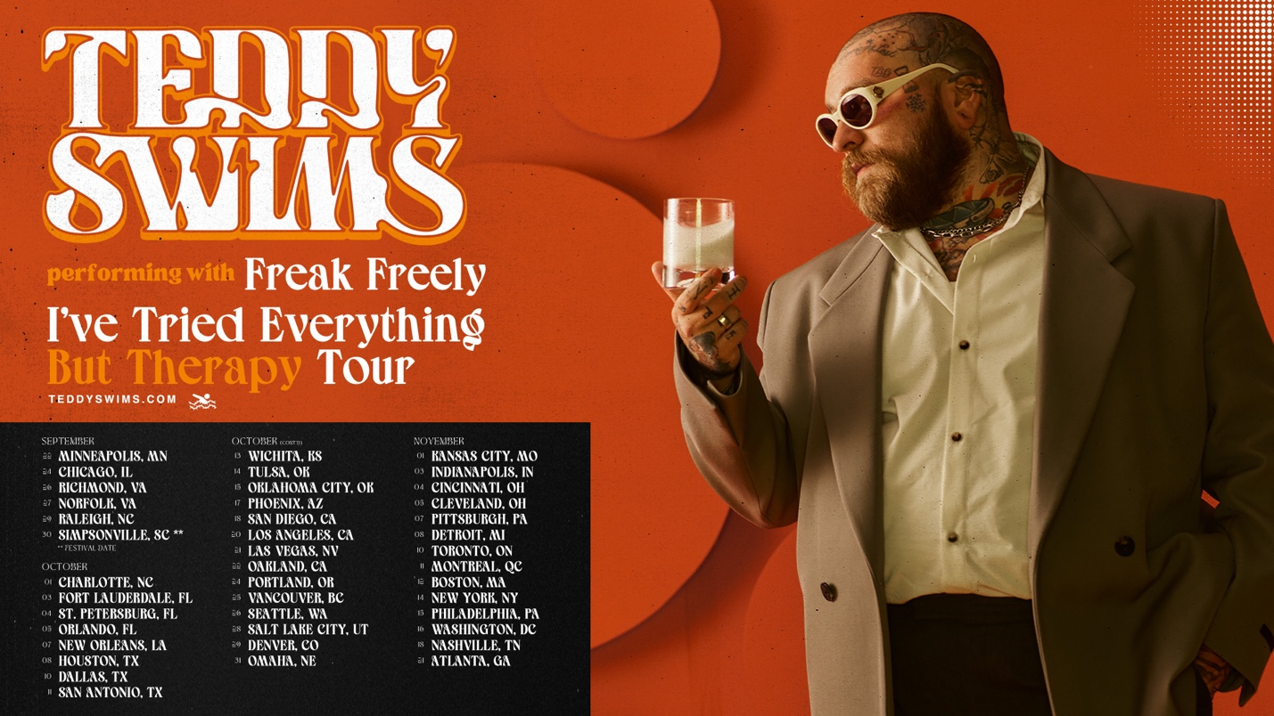
June 5, 2023 (Los Angeles, CA) — Today, genre-blurring singer-songwriter Teddy Swims announces his highly anticipated Fall 2023 North American tour. Kicking off in Minneapolis on September 22nd, the I’ve Tried Everything But Therapy Tour includes stops in Chicago (The Riviera), Los Angeles (The Wiltern), New York City (Terminal 5), and Nashville (Ryman Auditorium) before wrapping up in his hometown of Atlanta (The Tabernacle) on November 21st. General on-sale begins Friday, June 9th at 10 am local time. Tickets are available HERE.

Citi is the official card of the Teddy Swims I've Tried Everything But Therapy Tour. Citi cardmembers will have access to presale tickets beginning Tuesday, June 6th at 8 am local time until Thursday, June 8th at 10 pm local time through the Citi Entertainment program. For complete presale details, visit www.citientertainment.com.

The announcement arrives in the midst of an exciting time for Teddy. 2023 has already proven to be a big year for him with a string of international headline shows in Germany, Asia, Australia, New Zealand, Ireland, and the UK. Teddy has also been hinting at a massive year ahead for new music — most recently, he shared his latest single “What More Can I Say,” a soulful throwback to old-school R&B. He also teamed up with Elley Duhé for “FACE MYSELF” and collaborated with X Ambassadors and Jac Ross for “Happy People.”

Last year, he released two acclaimed EPs, Sleep Is Exhausting and Tough Love. Those releases topped off a typically busy 2022 for Swims that included dropping a viral cover of Journey’s classic “Don’t Stop Believin’” that was reposted by celebrities like Jennifer Garner and Timbaland. He also performed the song on America’s Got Talent with season 14 winner Kodi Lee and Journey founder and guitarist Neal Schon. Other 2022 highlights include lending his powerful pipes to ILLENIUM’s “All That Really Matters,” Meghan Trainor’s “Bad For Me,” and MK & Burns’ “Better.”

You don’t want to miss Teddy Swims as he brings his compelling live show on the road this year, showcasing his signature eclectic style across stages everywhere.

Teddy Swims 2023 Tour Dates:

Sep 22 Minneapolis, MN First Avenue
Sep 24 Chicago, IL Riviera Theatre
Sep 26 Richmond, VA The National
Sep 27 Norfolk, VA The NorVa
Sep 29 Raleigh, NC The Ritz
Sep 30 Greenville, SC Voyage Music Festival
Oct 1 Charlotte, NC The Fillmore Charlotte
Oct 3 Fort Lauderdale, FL Revolution Live
Oct 4 St. Petersburg, FL Jannus Live
Oct 5 Orlando, FL House of Blues Orlando
Oct 7 New Orleans, LA The Fillmore New Orleans
Oct 8 Houston, TX House of Blues Houston
Oct 10 Dallas, TX The Factory in Deep Ellum
Oct 11 San Antonio, TX Aztec Theatre
Oct 13 Wichita, KS TempleLive
Oct 14 Tulsa, OK Cain’s Ballroom
Oct 15 Oklahoma City, OK The Criterion
Oct 17 Phoenix, AZ The Van Buren
Oct 18 San Diego, CA SOMA – Mainstage
Oct 20 Los Angeles, CA The Wiltern
Oct 21 Las Vegas, NV Freemont Street Experience
Oct 22 Oakland, CA Fox Theater
Oct 24 Portland, OR Roseland Theater
Oct 25 Vancouver, BC Orpheum Theatre
Oct 26 Seattle, WA Showbox SoDo
Oct 28 Salt Lake City, UT Rockwell @ The Complex
Oct 29 Denver, CO Mission Ballroom
Oct 31 Omaha, NE The Admiral Theater
Nov 1 Kansas City, MO The Midland Theatre
Nov 3 Indianapolis, IN Egyptian Room at Old National Centre
Nov 4 Cincinnati, OH Bogart’s
Nov 5 Cleveland, OH Agora Theatre
Nov 7 Pittsburgh, PA Stage AE
Nov 8 Detroit, MI The Fillmore Detroit
Nov 10 Toronto, ON HISTORY
Nov 11 Montreal, QC Beanfield Theatre
Nov 12 Boston, MA Roadrunner
Nov 14 New York, NY Terminal 5
Nov 15 Philadelphia, PA The Fillmore Philadelphia
Nov 16 Washington, DC The Anthem
Nov 18 Nashville, TN Ryman Auditorium
Nov 21 Atlanta, GA Tabernacle

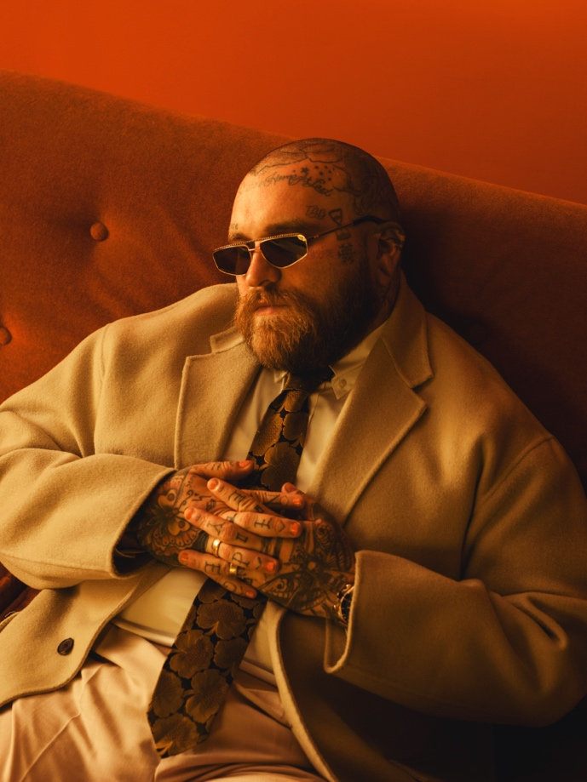
Download Hi-Res press photo HERE
Photo credit: Joseph Cultice

FOLLOW TEDDY SWIMS:
Official | Twitter | Instagram | Facebook | YouTube | TikTok | Press Materials

For more information, please contact:

Darren Baber | Warner Records
Darren.Baber@warnerrecords.com

Regional: Delanee Wilson | Warner Records
Delanee.Wilson@warnerrecords.com

