WARREN ZEIDERS ANNOUNCES DEBUT ALBUM PRETTY LITTLE POISON
SET FOR AUGUST 25 RELEASE VIA WARNER RECORDS

“Tell Me Like It Is” Available Now
Listen HERE / Watch HERE

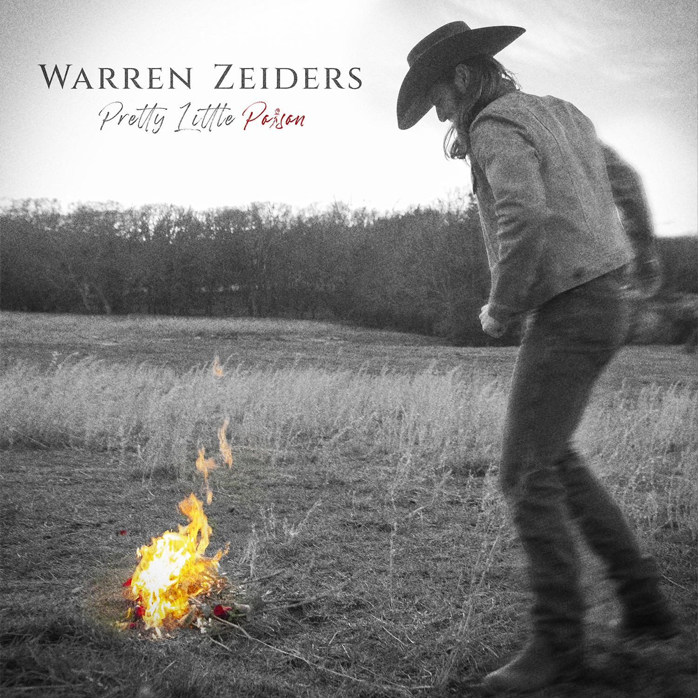
(Hi-res cover art HERE)

June 2, 2023 — (Los Angeles, CA) — Warren Zeiders has quickly risen from a college athlete to one of Nashville’s newest headliners at just 24 years old, and on August 25, he’ll release his debut LP Pretty Little Poison via Warner Records. Comprised of 14 tracks, four of which were produced by Bart Butler & Ryan Gore and the other 10 produced by Ross Copperman, the record is part road-warrior, part old-fashioned grit, and a multitude of genre influences that have catapulted him to one of country’s most interesting newcomers. Album track “Tell Me Like It Is” is available now — listen HERE and watch the lyric video HERE. Click HERE to pre-order the album.

​​Zeiders built his audience quickly, yet the old-school way — by taking his music directly to the people, armed with nothing more than his acoustic guitar and gravelly voice. This album Pretty Little Poison shows what he can do with an amplified band, two chart-topping producers and the best music of his songwriting career. The past two years have been a whirlwind period filled with milestones: his first national television appearance on The Kelly Clarkson Show; his first national tour, which sold out in 72 hours; his debut performance on the Grand Ole Opry stage; and even his first Top 40 hit on the Billboard charts, all before he began recording his debut album. Maybe that's why Pretty Little Poison brims with such excitement and self-assurance.

"A lot of this album is about a girl, and a lot of it is about me," says Zeiders, who fills the album with honest lyrics about life, love, and lessons learned. "I'm paying tribute to that classic country sound, but I'm keeping things modern, too. At the end of the day, I'm just putting my heart on my sleeve and putting myself onstage."

Zeiders' muscular brand of country music is as broad as his shoulders, which still bear the evidence of a longtime sports career. "God Only Knows"and "Comin' Down High" are southern rock anthems built for summertime parties and backwoods joyrides. Songs like "Painkiller" and "Love's A Leaving" explore the darkness of outlaw country. The bright choruses of "West Texas Weather" and "Some Whiskey" are showcases for his powerhouse vocals, while "Pretty Little Poison" — the album's title track and lead single — is country music at its most cinematic, pairing dusty western textures with a radio-ready refrain. "Inside Your Head," written by eight-time Grammy winner Chris Stapleton, makes room for the lap steel guitars and timeless twang of classic country. For Zeiders, whose viral cover of "Tennessee Whiskey" played such a crucial role in his own rise to success, featuring a Stapleton cut on Pretty Little Poison feels a whole lot like fate. He worked with a number of other songwriters, too, co-writing songs with Eric Paslay, Randy Montana, Ryan Beaver, Lee Thomas Miller, Benjy Davis, Austin Taylor Smith, Jarred Keim, and others.

"Faith, family, and athletics were the three pillars of my life, long before I started playing music," he says. "I haven't forgotten that. I'm always learning new things — if you stop doing that, you stop growing — but I'm staying true to who I am, too. This album is my story. It's who I am. It's who I've always been. I may not be playing lacrosse anymore, but I haven't lost the discipline or focus that I learned as an athlete. I still put in the work. I still push myself. I go onstage and treat it like it's a game day."

Zeiders’ Pretty Little Poison Tour “game days” are selling out across the country, and he just performed to a sold-out Ohio Stadium alongside George Strait, Chris Stapleton and Little Big Town. Next week, Zeiders will play the Chevy Riverfront Stage and the Spotify House at CMA Fest, plus he’ll play in the Folds of Honor Rock ‘n Jock Celebrity Softball game. For tickets, tour dates and more information, visit warrenzeiders.com.

Pretty Little Poison Tracklist:
- “Pretty Little Poison” (Warren Zeiders, Jarred Keim, Ryan Beaver)
- “Some Whiskey” (Warren Zeiders, Randy Montana, Mark Hollman)
- “Love’s A Leavin'” (Warren Zeiders, Ross Copperman, Joy Beth Taylor)
- “Tell Me Like It Is” (Warren Zeider, Rivers Rutherford, Warren Zeiders)
- “Black and Blue” (Warren Zeiders, Bart Butler, Joe Clemmons, Ryan Beaver)*
- “Weeping Willow” (Warren Zeiders, Randy Montana, Mark Hollman, Erik Dylan)*
- “Painkiller” (Warren Zeiders, Erik Dylan, Josh Phillips)*
- “Inside Your Head” (Chris Stapleton, Lee Thomas Miller)
- “Coming Down High” (Warren Zeiders, Bart Butler, Ryan Beaver, Benjy Davis)*
- “God Only Knows” (Warren Zeiders, Eric Paslay, Rob Crosby)
- “Drive You Crazy” (Warren Zeiders, Stephen Wilson Jr., Randy Montana)
- “West Texas Weather” (Warren Zeiders, Austin Taylor Smith)
- “Pittsburgh Steel” (Warren Zeiders, Randy Montana, Joe Fox )
- “Cowboys Ride Away” (Warren Zeiders, Ryan Beaver, Jared Keim)

*Produced by Bart Butler & Ryan Gore
Note: all other songs produced by Ross Copperman

WARREN ZEIDERS UPCOMING TOUR DATES:
Bold denotes newly Pretty Little Poison dates with A Thousand Horses as tour support
+denotes sold-out show

June 2 - Panama City Beach, FL - Gulf Coast Jam
June 3 - East Gadsden, AL - Bash! In The Bend
June 8 - Nashville, TN - CMA Fest
June 10 - Clinton, IA - Tailgate N’ Tallboys 2023
June 15 - Valparaiso, IN - Central Park Plaza
June 16 - North Lawrence, OH - Country Fest
June 17 - Bloomington, IL - Tailgate N’ Tallboys
June 22 - Wichita, KS - The Cotillion Ballroom
June 23 - Sioux Falls, SD - The District
June 24 - Clearwater, NE - Clearwater Rodeo
July 6 - Fort Loramie, OH - Country Concert 2023
July 7 - Independence, IA - Buchanan County Fairgrounds & Campgrounds
July 8 - Arthur, IL - Moultrie-Douglas County Fair
July 13 - Arnold’s Park, IA - Captain’s Getaway
July 14 - West Salem, WI - Country Boom 2023
July 15 - Brooklyn, MI - Faster Horses Festival 2023
July 27 - Three Forks, MT - Headwaters Country Jam 2023
July 28 - Casper, WY - The Gaslight Social
July 29 - Wahoo, NE - Saunders County Fairgrounds
Aug. 2 - Elma, WA - Grays Harbour County Fairgrounds
Aug. 3 - Klamath Falls, OR - Klamath County Fairgrounds
Aug. 4 - Sweet Home, OR - Oregon Jamboree Music Festival 2023
Aug. 5 - Quincy, WA - Watershed Festival 2023
Aug. 9 - Hermiston, OR - Umatilla County Fair
Aug. 10 - Great Falls, MT - The Newberry +
Aug. 11 - Jerome, ID - Jerome County Fairgrounds
Aug. 12 - Grand Junction, CO - Warehouse25sSixty-Five Kitchen & Bar
Aug. 18 - Jordan, NY - Kegs Canalside
Aug. 19 - Montreal, CA - Lasso 2023
Aug. 26 - Louisville, KY - Kentucky State Fair
Aug. 31 - Dewey Beach, DE - Bottle & Cork +
Sept. 1 - Philippi, WV - Barbour County Fair
Sept. 2 - Meshoppen, PA - Wyoming County Community Fair
Sept. 15 - Buffalo, NY - Town Ballroom
Sept. 16 - Pittsburgh, PA - Stage AE
Sept. 21 - Cleveland, OH - Agora Ballroom
Sept. 22 - Columbus, OH - KEMBA Live!
Sept. 23 - Harrisburg, PA - Southside Stage
Sept. 28 - Oklahoma City, OK - The Jones Assembly
Sept. 29 - Little Rock, AR - The Hall
Sept. 30 - New Orleans, LA - House of Blues New Orleans
Oct. 4 - Nashville, TN - Ryman Auditorium
Oct. 5 - Kansas City, MO - Uptown Theater
Oct. 12 - Orlando, FL - House of Blues Orlando
Oct. 13 - North Myrtle Beach, SC - House of Blues Myrtle Beach
Oct. 14 - Charlotte, NC - The Fillmore Charlotte
Oct. 19 - Silver Spring, MD - The Fillmore Silver Spring
Oct. 20 - Raleigh, NC - The Ritz
Oct. 21 - Greenville, SC - Greenville Country Music Fest
Oct. 26 - Louisville, KY - Paristown
Oct. 27 - Indianapolis, IN - Egyptian Room at Old National Centre
Oct. 28 - Detroit, MI - The Fillmore Detroit
Nov. 2 - Saint Louis, MO - The Pageant
Nov. 4 - Minneapolis, MN - The Fillmore Minneapolis
Nov. 9 - Huntington, NY - The Paramount
Nov. 10 - Boston, MA - House of Blues Boston
Nov. 11 - Philadelphia, PA - The Fillmore Philadelphia

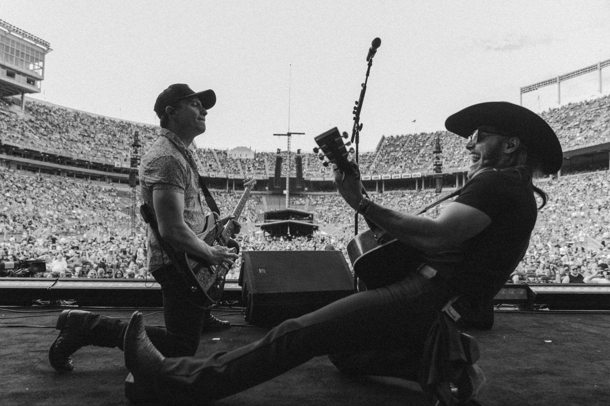
(Photo credit: Austin Screws)

# # #

FOLLOW WARREN ZEIDERS:
Facebook | Instagram | Twitter | TikTok | YouTube | Press Materials
PRESS PAGE:
shorefire.com/roster/warren-zeiders
﻿PRESS CONTACTS:
Jaclyn D. Carter | Shore Fire Media | jcarter@shorefire.com
Andrea Evenson | Shore Fire Media | aevenson@shorefire.com
Maria Eilert | Shore Fire Media | meilert@shorefire.com
Rick Gershon | Warner Records | rick.gershon@warnerrecords.com
