WARREN ZEIDERS EARNS RIAA PLATINUM CERTIFICATION FOR BREAKTHROUGH SINGLE “RIDE THE LIGHTNING” & CELEBRATES
100TH SHOW AT STAGECOACH

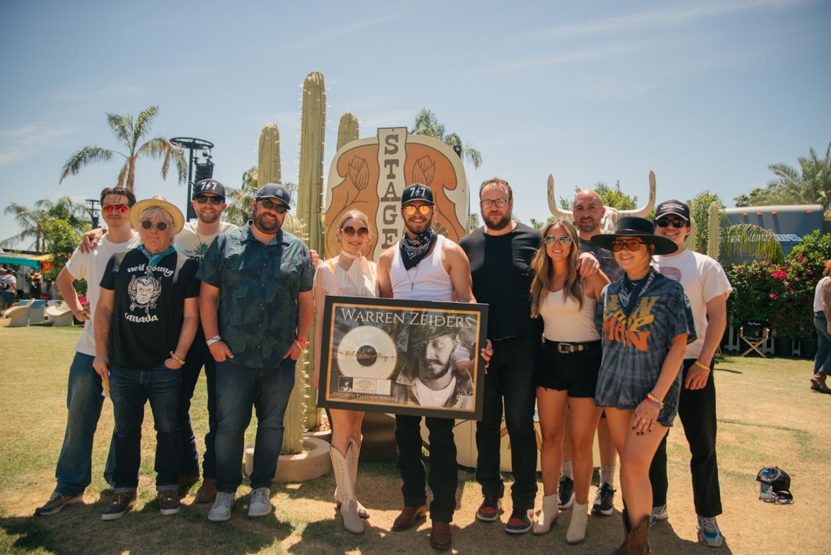

Download the high-res photo here

Photo ID (from L to R): Sam Riddle (Warner Records), Rick Gershon (Warner Records), Jared Platt (tour manager), Jeff Krones (CAA), Stacy Vee (Goldenvoice), Warren Zeiders, Rich Schaefer (AEG), Jamie Ernst (underscore works), Charly Salvatore (underscore works), Jordin Wentworth (underscore works), and Will Morrow (Warner Records) at Stagecoach in Indio, CA. Photo Credit: Austin Screws

On Sunday, April 30, , rising country star Warren Zeiders received the RIAA platinum certification for his standout single, “Ride The Lightning.” Zeiders was surprised with the plaque by SiriusXM’s Storme Warren at his Sunday Stagecoach performance on the T Mobile Mane Stage, which marked his 100th career show to date.

Watch the emotional surprise via SiriusXM here

As his debut single with Warner Records in 2021, “Ride The Lightning” catapulted Warren into one of the genre’s fastest-rising success stories in recent history. Released as part of his critically acclaimed 717 Tapes, the song was only the second Zeiders had ever written, leading PEOPLE Magazine to proclaim him as a “‘Wild Horse’ who sings about the truth.”

Zeiders – who has since garnered 894 million audio streams globally and 1.4 billion views on TikTok – recently released his Pretty Little Poison (Sampler) EP. A taste of what’s to come on his upcoming Warner Records debut LP, the collection includes the powerful title track (watch the official music video here) and the poignant Lee Miller and Chris Stapleton-penned breakup ballad “Inside Your Head” – listen to all four tracks here. He also recently extended his Pretty Little Poison headlining tour following his sold-out Spring run, which will kick off in September and include Warren’s first headlining show at Nashville’s Ryman Auditorium.

WARREN ZEIDERS UPCOMING TOUR DATES:
Bold denotes newly Pretty Little Poison dates w. A Thousand Horses as tour support
+denotes sold-out show

May 26 - Roanoke, VA - Dr. Pepper Park at The Bridges
May 27 - Columbus, OH - Buckeye Country Superfest
June 2 - Panama City Beach, FL - Gulf Coast Jam
June 3 - East Gadsden, AL - Bash! In The Bend
June 8 - Nashville, TN - CMA Fest
June 10 - Clinton, IA - Tailgate N’ Tallboys 2023
June 15 - Valparaiso, IN - Central Park Plaza
June 16 - North Lawrence, OH - Country Fest
June 17 - Bloomington, IL - Tailgate N’ Tallboys
June 22 - Wichita, KS - The Cotillion Ballroom
June 23 - Sioux Falls, SD - The District
June 24 - Clearwater, NE - Clearwater Rodeo
July 6 - Fort Loramie, OH - Country Concert 2023
July 7 - Independence, IA - Buchanan County Fairgrounds & Campgrounds
July 8 - Arthur, IL - Moultrie-Douglas County Fair
July 13 - Arnold’s Park, IA - Captain’s Getaway
July 14 - West Salem, WI - Country Boom 2023
July 15 - Brooklyn, MI - Faster Horses Festival 2023
July 27 - Three Forks, MT - Headwaters Country Jam 2023
July 29 - Wahoo, NE - Saunders County Fairgrounds
Aug. 2 - Elma, WA - Grays Harbour County Fairgrounds
Aug. 3 - Klamath Falls, OR - Klamath County Fairgrounds
Aug. 4 - Sweet Home, OR - Oregon Jamboree Music Festival 2023
Aug. 5 - Quincy, WA - Watershed Festival 2023
Aug. 9 - Hermiston, OR - Umatilla County Fair
Aug. 10 - Great Falls, MT - The Newberry +
Aug. 11 - Jerome, ID - Jerome County Fairgrounds
Aug. 12 - Grand Junction, CO - Warehouse25sSixty-Five Kitchen & Bar
Aug. 18 - Jordan, NY - Kegs Canalside
Aug. 19 - Montreal, CA - Lasso 2023
Aug. 31 - Dewey Beach, DE - Bottle & Cork +
Sept. 1 - Philippi, WV - Barbour County Fair
Sept. 2 - Meshoppen, PA - Wyoming County Community Fair
Sept. 15 - Buffalo, NY - Town Ballroom
Sept. 16 - Pittsburgh, PA - Stage AE
Sept. 21 - Cleveland, OH - Agora Ballroom
Sept. 22 - Columbus, OH - KEMBA Live!
Sept. 28 - Oklahoma City, OK - The Jones Assembly
Sept. 29 - Little Rock, AR - The Hall
Sept. 30 - New Orleans, LA - House of Blues New Orleans
Oct. 4 - Nashville, TN - Ryman Auditorium
Oct. 5 - Kansas City, MO - Uptown Theater
Oct. 12 - Orlando, FL - House of Blues Orlando
Oct. 13 - North Myrtle Beach, SC - House of Blues Myrtle Beach
Oct. 14 - Charlotte, NC - The Fillmore Charlotte
Oct. 19 - Silver Spring, MD - The Fillmore Silver Spring
Oct. 20 - Raleigh, NC - The Ritz
Oct. 21 - Greenville, SC - Greenville Country Music Fest
Oct. 26 - Louisville, KY - Paristown
Oct. 27 - Indianapolis, IN - Egyptian Room at Old National Centre
Oct. 28 - Detroit, MI - The Fillmore Detroit
Nov. 2 - Saint Louis, MO - The Pageant
Nov. 4 - Minneapolis, MN - The Fillmore Minneapolis
Nov. 9 - Huntington, NY - The Paramount
Nov. 10 - Boston, MA - House of Blues Boston
Nov. 11 - Philadelphia, PA - The Fillmore Philadelphia

###

FOLLOW WARREN ZEIDERS:
Facebook | Instagram | Twitter | TikTok | YouTube

﻿PRESS CONTACTS:
Rick Gershon | Warner Records | rick.gershon@warnerrecords.com
Jaclyn D. Carter | Shore Fire Media | jcarter@shorefire.com

