NEW ALBUM BACK TO THE WATER BELOW TO
BE RELEASED SEPTEMBER 8 VIA WARNER RECORDS
PRE-ORDER HERE

THE NEW SINGLE “MOUNTAINS AT MIDNIGHT” AVAILABLE NOW
LISTEN HERE / WATCH THE OFFICIAL VIDEO HERE

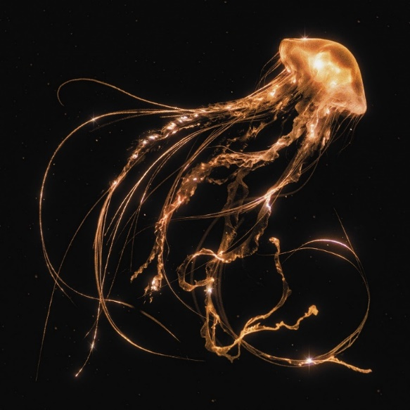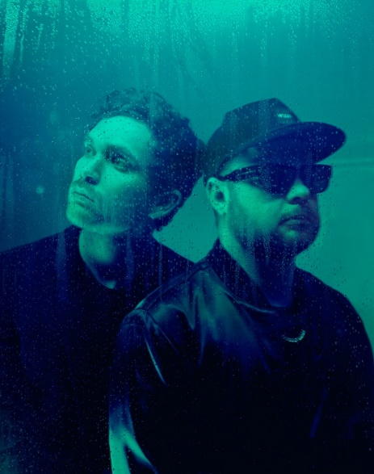
(Download high-res Back To The Water Below artwork HERE / Royal Blood photo by Tom Beard HERE)

May 25, 2023 (Los Angeles, CA) — Today, Royal Blood ignite an epic summer ahead as they announce the September 8 release of their fourth album Back To The Water Below and share its lead single “Mountains At Midnight”. Listen HERE and watch the official video HERE.

From the very beginning, Royal Blood’s story has been one of two life-long friends whose shared passion and dedication for writing and performing has led them on a remarkable adventure together – a story that has yet to be repeated and is a feat as rare as it is remarkable. Long before Royal Blood were even formed, they spent years together in various bands playing to half empty bars around Brighton, and only then did they suddenly become a decade-in-the-making overnight success story. One day, they were plotting how to recoup the meager £300 they had spent on their first recording, but within a year they were at the top of UK album charts, storming Glastonbury and winning the BRIT Award for Best British Group.

Throughout, their story has been one of independence. Relying on their friendship and intuitive musicianship to guide them through as they were catapulted into theaters and arenas around the world, favoring working independently away from prying eyes rather than enlisting the help of the latest big-name co-writer. Their victories have come from hard work, prodigious songwriting, fierce performances, and a smidgeon of good fortune. That spirit of independence continues into Back To The Water Below, which saw them self-produce an entire album for the very first time. It was a process which cancelled out the noise of any external influences, while also allowing them the convenience to write at their own studio in Brighton whenever inspiration struck.

They discovered that the best ideas were the result of following their instincts — their unspoken, subconscious connection honed over the course of 15 years playing music together. Just as importantly, they cast aside any preconceptions of what Royal Blood should be. They allowed themselves the freedom to embrace other ideas, at times being guided by melodies rather than riffs and rhythms, and in others deploying whatever instrumentation they felt best complemented the songs. If in doubt, they remembered a nugget of advice offered by Rick Rubin – that the sound of Royal Blood isn’t defined by genre or the instruments that they play, but by the unique chemistry forged by the two friends.

But as the single “Mountains At Midnight” proves, sometimes the result was a fresh take on the old school Royal Blood prototype – albeit with a supercharged rush. As we’ve come to expect, Mike Kerr inventively layers a heavyweight wall-of-sound solely with his bass, while Ben Thatcher’s rhythms simultaneously swing with a spacious groove while pummelling us into submission. Meanwhile, Mike’s lyrics complement the song’s ominous, foreboding ambiance with vehement menace: “I’m a ticking timebomb hooligan come to light your fuse / 24-carat thug in a velvet glove.”

Elsewhere, Royal Blood present plenty of surprises without ever compromising the essence of their identity. “Shiner In The Dark” sets a rock ‘n roll swagger to the tight, danceable rhythms that defined the 2021 album Typhoons. Devoid of distortion, “The Firing Line” represents a bigger departure, its ‘90s alt-rock tone and an underbelly of psychedelia later elevated by a chiming piano melody. “Pull Me Through” goes further still, uniting the plaintive piano that fans loved in the live favourite “All We Have Is Now” with a full-blooded denouement. They’re also songs which will not only provide a broader spectrum of moods for live shows, but that will offer the dynamic contrast to amplify the power of their most fiery moments.

Ben Thatcher says, “I think this record was about letting the ideas take us where they needed to go. If there was a song that was calling us to do something that wasn’t typically what we’re known for, that’s where we’re going to go. The songs are in charge and if that means having a record that’s quite varied that’s what we’re going to go for, rather than trying to shoehorn everything into the same world. As a result, we’ve made a record that’s a bit of a rollercoaster. It’s everything we could do.”

Reflecting upon their journey so far, Mike Kerr adds, “No-one saw the years of us playing in loads of bands to no-one, that all gets swept under the carpet because the other story is magical and much more wondrous. Luck is where passion meets opportunity. We got our golden ticket and walked out as tiny ninjas. We were in the right place at the right time, and we have to remember to give ourselves the credit that we didn’t get into this position by winning a quiz show, we put in a serious amount of work. It’s taken us four albums to realise this isn’t luck, we’re good and we’re committed to this.”

Back To The Water Below is now available to pre-order HERE. In addition to its digital release, physical formats include deluxe vinyl (packaged with a bonus 7” featuring two additional tracks) and two cassettes, all of which are available exclusively from Royal Blood’s official store. Amazon will stock an exclusive gold vinyl, while HMV (UK only) and select indie stores offer an exclusive clear vinyl. The range is completed by a CD and a regular black vinyl.

Back To The Water Below tracklist:

- Mountains At Midnight
- Shiner In The Dark
- Pull Me Through
- The Firing Line
- Tell Me When It’s Too Late
- Triggers
- How Many More Times
- High Waters
- There Goes My Cool
- Waves

Deluxe Edition 7” single bonus tracks:
- Supermodel Avalanches
- Everything’s Fine

In the meantime, Royal Blood are playing a host of leading UK and European summer festivals and some stadium shows as special guests to Muse, culminating with a landmark homecoming headline show at Brighton Beach. A pair of US festival dates have already been announced. US tour details to follow soon. Click HERE for ticket information and a full list of all international shows.

US Festival Dates – on sale now:
Sep 16 Asbury Park, NJ Sea. Hear. Now Festival
Sep 21 Louisville, KY Louder Than Life Festival

# # #

For more information, please contact:
National: Rick Gershon Rick.Gershon@warnerrecords.com
Regional: Delanee Wilson Delanee.wilson@warnerrecords.com

Follow Royal Blood:
Website | Spotify | Apple Music | YouTube | Facebook | Instagram | Twitter | TikTok | Press Materials

