PECOS & THE ROOFTOPS’ SELF-TITLED DEBUT ALBUM
OUT NOW VIA WARNER RECORDS

16-TRACK LP FEATURES THE SINGLES “5AM,” “LAST THING I REMEMBER,” “HURT NO MORE,” AND “SHE SAYS”

LISTEN HERE / WATCH HERE

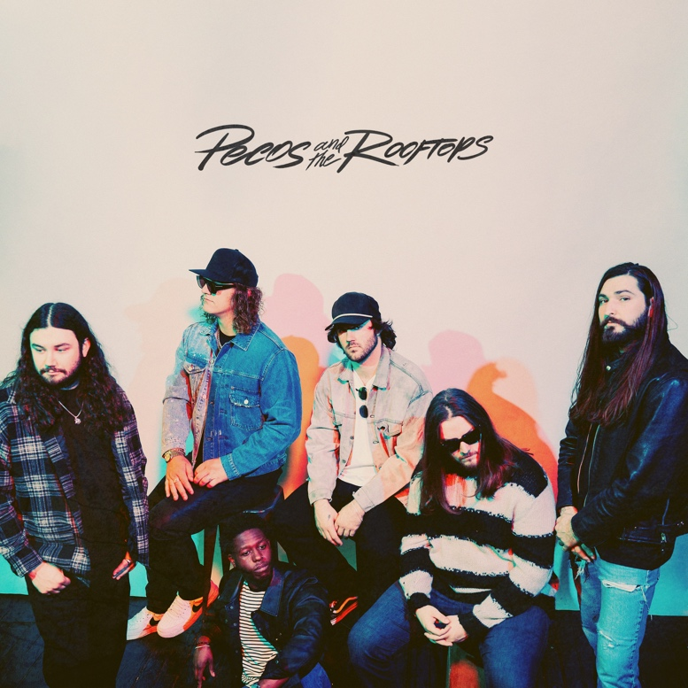
(Download hi-res album art HERE)

June 23, 2023 (Los Angeles, CA) — Platinum-certified rising Texas-based country rock band Pecos & The Rooftops release their highly anticipated, self-titled debut album today via Warner Records. Emerging with a sharp signature style and an unrivaled live presence proven one gig at a time, the rising sextet is known for their loud ‘n rowdy, hard rockin’ live shows that have taken them from the tough Texas club scene to festival stages coast to coast since 2019. The album boasts fan favorite singles “5AM,” “Hurt No More,” “Last Thing I Remember,” “Bricks” and focus track “She Says.” Frontman Pecos Hurley explains, "’She Says’ is a song that was really fun to write. I sat down in my home studio with my first friend I made in the music industry, Canaan Bryce, and started playing the chords and he had the idea for the song, so we ran with it. It’s one of my personal favorites on the album and also to play live."

Click HERE to stream “She Says” and HERE to watch the lyric video. Click HERE to listen to the album.

Pecos & The Rooftops have been perfecting a signature heavy blend of lowdown country and classic rock since their inception with the band living in a big five-bedroom house in Lubbock, Texas. Formed in 2019 by a tight-knit squad of college friends, the band outfits their soulful Americana with muscular guitar grit, yet remains tuneful and melodic. They’ve carved out a singular niche for themselves in the rich songwriting tradition of their home state, as evidenced by their debut Warner Records single “5AM,” which has amassed 8.6 million global streams since its release in March. Anchored by the heart-baring songwriting and booming voice of former Marine Pecos Hurley, the band is rounded out by top-tier players and songwriters Brandon Jones (rhythm guitar), Zack Foster (lead guitar), Kalen Davis (bass), Garrett Peltier (drums) and Hunter Cassell (guitars & keys).

Pecos & The Rooftops chose their name—a nod to the part of the house they’d hang out, drink beers, and jam on—just before self-releasing their debut single, 2019’s slow-burning “This Damn Song.” It was a runaway success, earning an RIAA Platinum certification and going on to rack up more than 300 million streams globally. Deciding to ride the wave for as long as they could, the band hit the road immediately after and haven’t stopped since, touring relentlessly on the club and festival circuit opening for the likes of rising country star Zach Bryan. They released the Red Eye EP in 2020, expanding on their already solid sound with extra emphasis on guitar structures and complex yet melodic arrangements, hinting at jazz and psychedelic influences.

Hurley has a gift for exploring the shadowy sides of life through his songwriting, offering a clear-eyed and unflinching look at heartbreak, disconnection, self-medication, and wrestling with dark times. Commenting on Hurley’s songwriting chops, Whiskey Riff proclaimed, “They know how to hit you where it hurts, as front man Pecos Hurley incorporates some of the most brutally honest and relatable lyrics I’ve ever heard.”

Pecos & The Rooftops have earned a devoted fan base who’ve come out to support them both online and on the road, with the band garnering over 434 million global streams to date and more than 112 million video views. They’re currently on a nationwide headline tour with more dates to be announced soon. “At the end of the day, I just want to help people with our music, honestly,” Hurley says. Pecos & the Rooftops are set to do that and much, much more.

PECOS & THE ROOFTOPS TRACKLISTING
- 5AM
- Hurt No More
- Last Thing I Remember
- Bricks
- She Says
- Good Reason
- Angel in the Dark
- Happy
- Like the Movies
- This Damn Song
- Worst Way
- Nothing New
- Infamous
- Cabin Fever
- 9 Lives
- Memories

Pecos & The Rooftops 2023 Tour Dates
*With Koe Wetzel

*Jun 23 Reno, NV Grand Sierra Resort and Casino
Jun 24 Filer, ID Gordy’s HWY 30 Music Festival 2023
*Jun 30 Des Moines, IA Lauridsen Amphitheater at Water Works Park
*Jul 01 Dubuque, IA Five Flags Center
Jul 07 Belton, TX Schoepf’s BBQ
Jul 08 New Braunfels, TX Whitewater Amphitheater
Jul 27 Three Forks, MT Headwaters Country Jam 2023
Aug 03 Kansas City, MO KC Live!+
Aug 19 Helix, OR Wheatstock Music Festival 2023

# # #
Warner Records Contacts:
National: Rick Gershon | rick.gershon@warnerrecords.com
Regional/Tour: Delanee Wilson | Delanee.wilson@warnerrecords.com

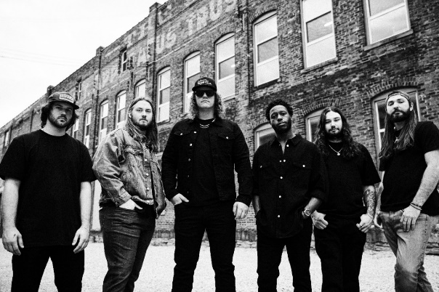
(Click HERE for hi-res by Nick Fancher)

FOLLOW PECOS & THE ROOFTOPS:
Website | Twitter | Instagram | TikTok | YouTube | Press Materials

