THE FLAMING LIPS TO RELEASE NEW PINK VINYL EP HYPNOTIST ON JUNE 16
INCLUDES RARITIES FROM YOSHIMI BATTLES THE PINK ROBOTS 20TH ANNIVERSARY BOX SET AVAILABLE ON VINYL FOR THE FIRST TIME
PRE-ORDER HERE / WATCH HERE
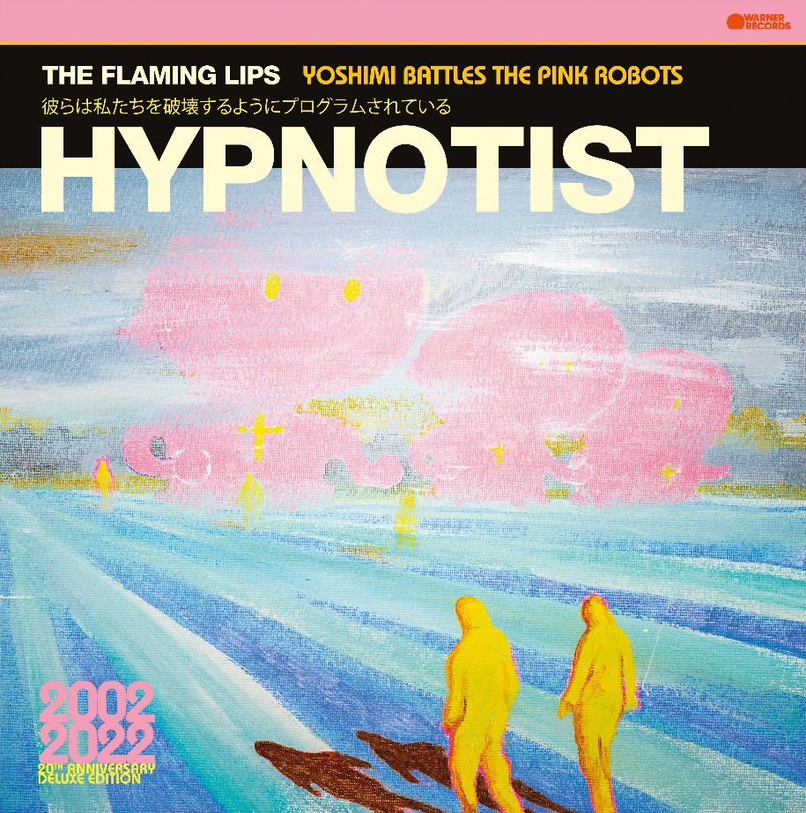
(Click HERE for Hi-res Cover Art)

May 4, 2023 (Los Angeles, CA) — The Flaming Lips will unveil a new limited-edition vinyl EP entitled Hypnotist on June 16. Click HERE to pre-order the exclusive pink pressing.

It notably collects four fan favorite tracks previously only available on the 6-CD Yoshimi Battles the Pink Robots 20th Anniversary Box Set. Now, they grace the 32-minute Hypnotist giving the songs a vinyl release for the very first time. The tracklisting notably boasts the immersive 24-minute sonic head-trip “Psychedelic Hypnotist Daydream (demo),” which unfurls as one of the group’s most epic gems to date. Additionally, it includes the “Duck Dodgers Theme (Duck Dodgers Demo: With Wayne Scratch Vocal),” “I Know I’ve Got To Make That Dream The Real Thing (Demo),” and, finally, “Do You Realize?? (Instrumental).” Click HERE to watch Wayne Coyne revisit the original 4-track recording of “Psychedelic Hypnotist Daydream.”

Other recent vinyl releases include two sought-after fan favorite Eps. Fight Test (on Ruby Red Vinyl) and Ego Tripping at the Gates of Hell (Glow In the dark Green Vinyl) are available on limited edition vinyl now. Click HERE to purchase.

Also available now is the Yoshimi Battles the Pink Robots: 20th Anniversary Edition 6-CD box set (100 tracks), filled with original album & EP tracks, plus a plethora of B-Sides, demos, live radio sessions and previously unreleased rarities. The 5-LP box set (56 tracks) was released on April 14.

The Flaming Lips are performing Yoshimi Battles the Pink Robots in its entirety at select venues around the world. Click HERE for details.

TRACKLISTING:
SIDE A:
1. Psychedelic Hypnotist Daydream (Demo)

SIDE B:
1. Duck Dodgers Theme (Duck Dodgers Demo: With Wayne Scratch Vocal)
2. I Know I've Got To Make That Dream The Real Thing (Demo)
3. Do You Realize?? (Instrumental)

The Flaming Lips On Tour 2023:
May 05 Chicago, IL The Salt Shed
May 07 Atlanta, GA Shaky Knees Festival
May 08 Charlotte, NC The Fillmore
May 10 Knoxville, TN Tennessee Theatre
May 11 Nashville, TN Ryman Auditorium
May 25 Washington, DC The Anthem
May 27 Boston, MA Boston Calling Festival
Jun 03 Jackson, MS Cathead Jam
Jun 08 Brooklyn, NY Kings Theatre
Jun 10 Bloomington, IN Granfalloon Festival
Jun 11 Cleveland, OH Agora Theater & Ballroom
Jun 13 Milwaukee, WI The Riverside Theater
Jun 14 St. Louis, MO Saint Louis Music Park
Jun 16 Omaha, NE Steelhouse
Jun 17 Tulsa, OK Tulsa Theater
Aug 02 Detroit, MI The Fillmore
Aug 04 Montreal, QC Osheaga Festival
Aug 06 Philadelphia, PA The Fillmore
Aug 07 New Haven, CT College Street Music Hall
Aug 18 Los Angeles, CA YouTube Theater
Aug 20 San Francisco, CA Stern Grove Festival
Aug 22 Portland, OR Pioneer Courthouse Square
Aug 23 Seattle, WA Woodland Park Zoo
Aug 25 Bonner, MT KettleHouse Amphitheatre
Aug 26 Ogden, UT Ogden Twilight
Nov 04 Mexico City, MX Festival Hipnosis

Released in July 2002, the sci-fi-themed quasi-concept album Yoshimi Battles the Pink Robots remains the commercial high-water mark in The Flaming Lips’ wild four-decade journey, giving them their first RIAA certified Gold Record. As the eagerly awaited follow-up to 1999’s masterwork The Soft Bulletin, Yoshimi proved that singer/guitarist Wayne Coyne and multi-instrumentalist Steven Drozd had yet another masterpiece in them. The record yielded the band’s top-streamed track, “Do You Realize??” (a timeless stargazing anthem that, in 2009, was named the Official Rock Song of the band’s native Oklahoma) and also landed the Lips their first-ever GRAMMY Award® win for the cosmic album-closing instrumental “Approaching Pavonis Mons by Balloon (Utopia Planitia).” Click HERE to view and share “Wayne listening to the multi-tracks for “Do You Realize??”

About The Flaming Lips:
Formed in Oklahoma City, OK in 1983, The Flaming Lips have since become one of the most iconic, influential, unpredictable, and vital forces in American alternative rock music. The band has garnered three GRAMMY® Awards, a Tony nomination, and an RIAA Gold-certified Record for Yoshimi Battles the Pink Robots. Q Magazine named them one of the “50 Bands to See Before You Die.” The band has made countless late night television appearances, appeared in a Super Bowl commercial, contributed to many film soundtracks, and collaborated with artists such as Miley Cyrus, Coldplay’s Chris Martin, Kacey Musgraves, Yoko Ono, The Chemical Brothers, and many more. Most recently The LIPS have recorded an album of Nick Cave covers featuring vocalist Nell Smith called “Where The Viaduct Blooms.” They have set countless records, broken attendance records, have a hometown street named in their honor, created spectacular interactive audio/visual events now regarded as legendary. Front man Wayne Coyne has been recognized for works of art that graced many LIPS album covers along with his traveling art exhibit (and subsequent album) “The King’s Mouth,” an audiovisual art installation that has been featured in many contemporary art museums around the US. Their latest LP, American Head, marks a return to a more melodic and song-oriented body of work and has critically been lauded as their best work in years placing on several “Year End/Best Of lists” around the world. Evan after a combination of 23 studio recordings, 16 singles, 11 compilations, 11 EP’s and 11 self-released experimental collaborative oddities released in various forms, quantities and unique mediums, The Flaming Lips remain in a creative apex that has no bounds. To that end, they have become an American Treasure and created a genre all to themselves.

# # #
For further information, contact Warner Records:
National: Rick.Gershon@warnerrecords.com
Regional: Delanee.Wilson@warnerrecords.com

Follow The Flaming Lips:
Website | Twitter | Facebook | YouTube | TikTok | Spotify | Press Materials

