THE FLAMING LIPS YOSHIMI BATTLES THE PINK ROBOTS: 20TH ANNIVERSARY EDITION VINYL BOX SET IS AVAILABLE NOW
THE COLLECTION FEATURES 2002 ALBUM ALONG WITH EPs, B-SIDES, DEMOS, RADIO SESSIONS, LIVE RECORDINGS & MORE
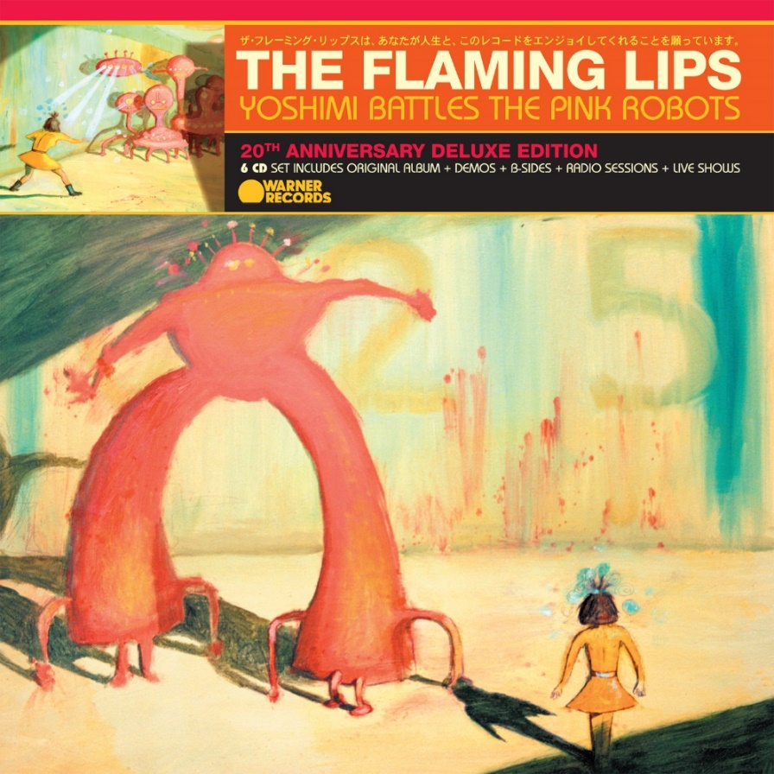
(Download Hi-Res artwork HERE)

April 14, 2024 — (Los Angeles, CA): Today, The Flaming Lips celebrate the 20th-anniversary of their classic 2002 album Yoshimi Battles the Pink Robots with the release of an expansive box set that also includes B-sides, demos, remixes, radio sessions, live tracks, and other assorted rarities from the era. The LP box set has 40 tracks never released on vinyl and over 30 previously unreleased tracks — 56 in total — across 5 LPs. Yoshimi Battles the Pink Robots: 20th Anniversary Edition is available now via Warner Records on all streaming services. There is also a limited edition D2C exclusive edition of the 20th Anniversary deluxe 5 LP vinyl box set pressed on Baby Pink vinyl — order HERE. Click HERE to check out a revised video of "Do You Realize??," and click HERE to watch Wayne Coyne unbox the collection.

Over the course of 2023, all material released from the November 2022 6-CD box set will also make its way to vinyl, including two live albums from that edition and the 25-minute demo “Psychedelic Hypnotist Daydream.”

Also available now are Fight Test (Ruby Red Vinyl) and Ego Tripping at the Gates of Hell (Glow In The Dark Green Vinyl) on vinyl disc for the first time and the 6-CD box set edition of YOSHIMI featuring 100 tracks, many previously unreleased. Order HERE and order new Yoshimi T-shirts designed for the 20th Anniversary HERE.

Starting Tuesday, April 25th in London, The Flaming Lips will begin performing Yoshimi Battles the Pink Robots in its entirety at select venues around the world. Click HERE for details.

The Flaming Lips On Tour 2023:
Apr 25 London, UK Troxy
Apr 28 London, UK Eventim Apollo
Apr 29 Manchester, UK O2 Apollo
May 05 Chicago, IL The Salt Shed
May 07 Atlanta, GA Shaky Knees Festival
May 08 Charlotte, NC The Fillmore
May 10 Knoxville, TN Tennessee Theatre
May 11 Nashville, TN Ryman Auditorium
May 25 Washington, DC The Anthem
May 27 Boston, MA Boston Calling Festival
Jun 03 Jackson, MS Cathead Jam
Jun 08 Brooklyn, NY Kings Theatre
Jun 10 Bloomington, IN Granfalloon Festival
Jun 11 Cleveland, OH Agora Theater & Ballroom
Jun 13 Milwaukee, WI The Riverside Theater
Jun 14 St. Louis, MO Saint Louis Music Park
Jun 16 Omaha, NE Steelhouse
Jun 17 Tulsa, OK Tulsa Theater
Aug 02 Detroit, MI The Fillmore
Aug 04 Montreal, QC Osheaga Festival
Aug 06 Philadelphia, PA The Fillmore
Aug 07 New Haven, CT Colege Street Music Hall
Aug 18 Los Angeles, CA YouTube Theater
Aug 22 Portland, OR Pioneer Courthouse Square
Aug 23 Seattle, WA Woodland Park Zoo
Aug 25 Bonner, MT KettleHouse Amphitheatre
Aug 26 Ogden, UT Ogden Twilight

Released in July 2002, Yoshimi Battles the Pink Robots remains the commercial high-water mark in The Flaming Lips ‘wild four-decade journey, giving the GRAMMY® award-winners their first RIAA certified Gold Record. As the eagerly awaited follow-up to 1999’s masterwork, The Soft Bulletin, Yoshimi proved that singer/guitarist Wayne Coyne, and multi-instrumentalist Steven Drozd had yet another masterpiece in them.

Yoshimi Battles the Pink Robots is a sci-fi-themed quasi-concept album that cast The Flaming Lips’ most playful and profound songs to date in a wondrous swirl of ambient electronics, digital beats, and psychedelic splendor. The record yielded the band’s top-streamed track, “Do You Realize??” (a timeless stargazing anthem that, in 2009, was named the Official Rock Song of the band’s native Oklahoma) and also landed the Lips their first-ever Grammy Award® win for the cosmic album-closing instrumental “Approaching Pavonis Mons by Balloon (Utopia Planitia).” Click HERE to view and share “Wayne listening to the multi-tracks for “Do You Realize??”

The 20th Anniversary Deluxe Edition provides a complete 360-degree view of the band’s creativity during this period. Several unheard demos show a rare peak at the band’s creative process. The box set also collects B-sides and outtakes, from epic fan favorites like “Assassination of the Sun” to fun, folky serenades like “Thank You Jack White (For the Fiber-Optic Jesus You Gave Me).” There is also a treasure trove of radio sessions including idiosyncratic overhauls of Pink Floyd’s “Lucifer Sam” and “Breathe,” Radiohead’s “Knives Out,” and Kylie Minogue’s “Can’t Get You Out of My Head.” In addition, the set includes a lush instrumental version of “Do You Realize??,” that has been requested by fans to play at both weddings and funerals.

5 LP Vinyl Box Set
LP 1 - Original Album
Side 1
- Fight Test
- One More Robot/Sympathy 3000-21
- Yoshimi Battles The Pink Robots Part 1
- Yoshimi Battles The Pink Robots Part 2
- In The Morning Of The Magicians
Side 2
- Ego Tripping At The Gates of Hell
- Are You A Hypnotist
- It's Summertime
- Do You Realize??
- All We Have Is Now
- Approaching Pavonis Mons By Balloon

LP 2 - Demos+
Side 3
- All My Life - Morning Of The Magicians (Demo)
- Ego Tripping Part 2 or 3 (Demo)
- Yoshimi Battles The Pink Robots (Demo)
- Hypnotist: Early Version (Demo)
- Epic Systems Delirium (Demo)
- In The Morning Of The Magicians (Demo)
Side 4
- Do You Realize?? 1st Chords Wayne (Demo)
- Do You Realize?? Steven New Part (Demo)
- Fight Test: Primitive Demo With Helium Voice
- If I Go Mad/Funeral In My Head (B-Side of Do You Realize?? UK CD 1)
- Syrtis Major (B-Side of Do You Realize?? UK CD 1)

LP 3 - Non-LP+
Side 5
- Yoshimi Battles The Pink Robots (Japanese Version)
- SpongeBob & Patrick Confront The Psychic Wall Of Energy (From The Spongebob SquarePants Movie)
- Seven Nation Army (From LateNightTales: The Flaming Lips)
- Go (Sparklehorse with The Flaming Lips) (Alternate Version From the Flaming Lips Archives)
- The Deterioration Of The Fight Or Flight Response (B-Side of Fight Test UK CD 1)
- Fight Test (Live on WXRT)
Side 6
- Do You Realize?? (Live on CD 101)
- Yoshimi Battles The Pink Robots (AOL Session)
- Waitin' For A Superman (Live on WXPN)
- In The Morning Of The Magicians (Live on KCRW)
- White Christmas (Live on WXPN)
- The Golden Path (The Chemical Brothers, feat. The Flaming Lips)

LP 4 - Radio Sessions
Side 7
- Suspicious Minds (Live on Cover-ed)
- Assassination Of The Sun (Live on BBC Radio 1) Maida Vale Session July 2002
- Can't Get You Out Of My Head (Live on BBC Radio 1) Maida Vale Session July 2002
- Do You Realize?? (Live on BBC Radio 1) Maida Vale Session July 2002
- One More Robot (Live on BBC Radio 1) Maida Vale Session July 2002
Side 8
- Do You Realize?? (Live on KEXP) Aug 5, 2002
- One More Robot (Live on KEXP) Aug 5, 2002
- Can't Get You Out Of My Head (Live on KEXP) Aug 5, 2002
- Yoshimi Battles The Pink Robots (Live on KEXP) Aug 5, 2002
- Breathe (Live on XFM) June 26 2003
- Ego Tripping At The Gates of Hell (Live on XFM) Nov 11, 2003
- Sunship Balloons (Live on XFM) Nov 11, 2003

LP 5 - Radio Sessions+
Side 9
- Fight Test (Live on XFM) June 26 2003
- Thank You Jack White (Live on XFM) June 26 2003
- Do You Realize?? (Live on XFM) July 11, 2002
- One More Robot (Live on XFM) July 11, 2002
- Can't Get You Out Of My Head (Live on XFM) July 11, 2002
Side 10
- Ego Tripping At The Gates of Hell (Live on BBC Radio 1) Oct 31, 2003 BBC Janice Long Show
- Yoshimi Battles The Pink Robots (Live on BBC Radio 1) Oct 31, 2003 BBC Janice Long Show
- Sunship Balloons (Live on BBC Radio 1) Oct 31, 2003 BBC Janice Long Show
- Up Above The Daily Hum (B-Side of Do You Realize?? UK CD 2)
- Xanthe Terra (B-Side of Do You Realize?? UK CD 2)

About The Flaming Lips:
Formed in Oklahoma City, OK in 1983, The Flaming Lips have since become one of the most iconic, influential, unpredictable, and vital forces in American alternative rock music. The band has garnered three GRAMMY® Awards, a Tony nomination, and an RIAA Gold-certified Record for Yoshimi Battles the Pink Robots. UK’s Q Magazine named them one of the “50 Bands to See Before You Die.” The band has made countless late night television appearances, appeared in a Super Bowl commercial, contributed to many film soundtracks, and collaborated with artists such as Miley Cyrus, Coldplay’s Chris Martin, Kacey Musgraves, Yoko Ono, The Chemical Brothers, and so many more. They have set countless records, broken records, created spectacular interactive audio/visual events now regarded as legendary. Front man Wayne Coyne has been recognized for works of art that graced many LIPS album covers along with his traveling art exhibit “The King’s Mouth,” an audiovisual art installation that has been featured in many contemporary art museums around the US. Their latest LP, American Head, marks a return to a more melodic and song-oriented body of work and has critically been lauded as their best work in years placing on several Year End/Best Of lists around the world. Evan after a combination of 22 studio recordings, 16 singles, 11 compilations, 11 EP’s and 11 self-released experimental collaborative oddities released in various forms, quantities and unique mediums, The Flaming Lips remain in a creative apex that has no bounds. To that end, they have become an American Treasure and created a genre all to themselves.

# # #
For further information, contact Warner Records:
National: Rick.Gershon@warnerrecords.com
Regional: Delanee.Wilson@warnerrecords.com

Follow The Flaming Lips:
Website | Twitter | Facebook | YouTube | TikTok | Spotify | Press Materials

