ZACH BRYAN’S CHART-TOPPING ALBUM AMERICAN HEARTBREAK
NOW CERTIFIED PLATINUM

WITH HIT SINGLE “SOMETHING IN THE ORANGE” CERTIFIED 4X PLATINUM

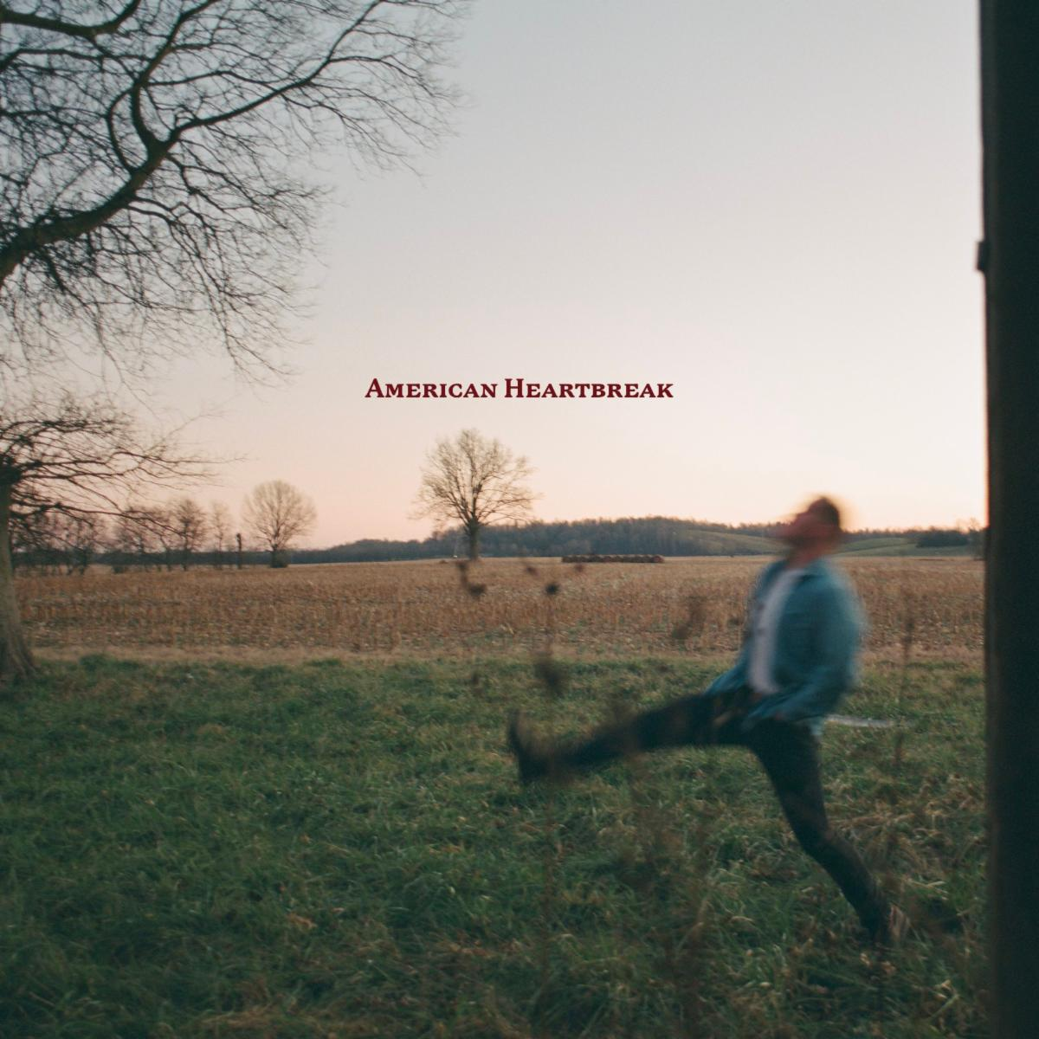
(Hi-res download HERE)

June 6, 2023 (Los Angeles, CA) – Its official — Zach Bryan’s American Heartbreak has been certified Platinum by the Recording Industry Association of America. Simultaneously, his hit single “Something in the Orange” is now 4x Platinum. Multiple tracks from the album have also garnered RIAA certification — to date, “The Good I’ll Do,” “Sun To Me,” and “From Austin” are certified Gold.

Originally released in April of 2022, “Something in the Orange” “has become his most recognizable hit,” said the New York Times, and was nominated for “Best Country Solo Performance” at the 65th Annual Grammy Awards.

As previously announced, the chart-topping 34-track album has remained in the Billboard 200 Chart for more than a year since its original release, after topping the Billboard Country Albums Chart at #1 and emerging as the Most Streamed Country Album on Spotify in 2022. Listen to American Heartbreak HERE via Warner Records.

Bryan’s completely sold-out Burn Burn Burn North American Tour pulls into Forest Hills Stadium NYC on June 23 and 24.

Zach Bryan Burn Burn Burn 2023 Tour:
* Indicates Festival Date
June 23 New York, NY Forest Hills Stadium
June 24 New York, NY Forest Hills Stadium
June 26 Denver, CO Red Rocks Amphitheatre
June 27 Denver, CO Red Rocks Amphitheatre
July 07 Milwaukee, WI Summerfest
*July 13 Chicago, IL Windy City Smokeout
*July 14-16 Whitefish, MT Under The Big Sky Festival
*July 20-July 22 Cullman, AL Rock The South
*July 23 Cheyenne, WY Cheyenne Frontier Days
*Aug 05 St. Charles, IA Hinterland Music Festival
Aug 07 Grand Rapids, MI Van Andel Arena
Aug 09 Minneapolis, MN Target Center
Aug 11 Tulsa, OK BOK Center
Aug 12 Tulsa, OK BOK Center
Aug 14 Sioux Falls, SD Denny Sanford Premier Center
Aug 17 Nampa, ID Ford Idaho Center
Aug 19 Las Vegas, NV T-Mobile Arena
Aug 20 Bakersfield, CA Mechanics Bank Arena
Aug 21 Oakland, CA Oakland Arena
Aug 23 Los Angeles, CA Crypto.com Arena
Aug 25 Glendale, AZ Desert Diamond Arena
Aug 27 Wichita, KS INTRUST Bank Arena
Aug 29 Lincoln, NE Pinnacle Bank Arena
Aug 30 Kansas City, MO T-Mobile Center
Oct 07 Opelika, AL Auburn Rodeo

# # #

For further information, contact:
Rick Gershon | Warner Records
Rick.Gershon@warnerrecords.com

FOLLOW ZACH BRYAN:
Website | Instagram | TikTok | Twitter | YouTube

