PATRICK DRONEY RETURNS WITH HYPNOTIC NEW
SINGLE “CAROLINE”
LISTEN HERE / WATCH HERE

ANXIOUSLY AWAITED NEW ALBUM SUBTITLES FOR FEELINGS
TO ARRIVE AUGUST 25
PRE-ORDER HERE

ANNOUNCES THE RUNAWAY FALL HEADLINE TOUR

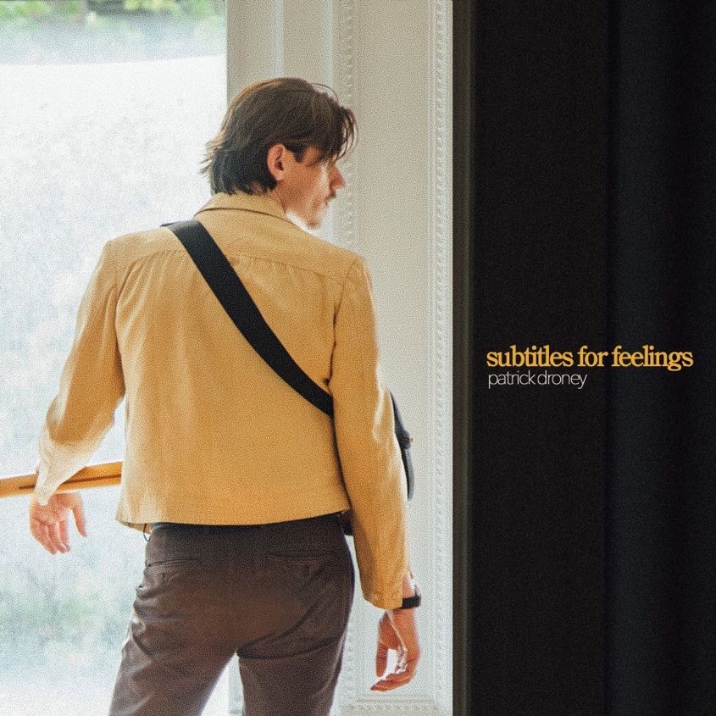
Download hi-res artwork HERE

July 7, 2023 (Los Angeles, CA) — Maintaining undeniable momentum this year, powerhouse singer, songwriter, producer, and guitarist extraordinaire Patrick Droney shares a brand-new single entitled “Caroline.” Listen HERE, and watch the video HERE, The song heralds the arrival of his anxiously awaited second full-length album, Subtitles For Feelings, arriving on August 25, via Warner Records. Click HERE to pre-order.

Droney also announces The Runaway Tour, his Fall 2023 North American headline run. Kicking off on September 27 in Boston, the tour takes Droney through Chicago, Austin and Los Angeles before wrapping up in New York City on October 10. Tickets go on sale Friday, July 14 at 9am local time. See full list of dates and purchase tickets HERE.

Co-written with Foy Vance and co-produced by Butch Walker and Droney, “Caroline” highlights his evolution. Neon synths glow in between a steady, stadium-ready beat. Meanwhile, his grizzled delivery accents confessional lyrics as he wonders, “You were never my girl, so why am I guessing? Caroline, where did you sleep last night?” This back-and-forth gives way to a hummable and hypnotic guitar lead, sustaining each note with raw emotion.

About the song, he commented, “I wrote ‘Caroline’ with my dear friend Foy Vance in Nashville last summer. It all started with the bridge, which really resonated with my followers. This track feels more connected to State of the Heart than any others on Subtitles for Feelings, so I thought this would be its perfect moment as a bridge to the new era. ‘Caroline’ was also my first production collaboration with the great Butch Walker whose music I discovered on One Tree Hill back in high school. Foy and Butch both have permanent places in my ‘songs that made me’ playlist, so having them on this record is a full-circle feeling.”

He initially teased Subtitles For Feelings with recent single “Go Getter.” Immediately, EUPHORIA. enthusiastically proclaimed, “‘Go Getter’ is a perfect mix of pop, adult contemporary, soul, and blues. The modern pop production is used to enhance the rock roots, while the layered choir section amplifies Droney’s drawling yet hypnotic presence behind the mic.”

Ultimately, Subtitles For Feelings collates raw emotions, moments, and memories over an enigmatic timeless and classic pop backdrop.

In between writing new music, Droney captivated audiences with performances at a Super Bowl LVII pre-game event, in the UK with The Eagles at Hyde Park and The Vamps at the O2 Arena, plus a string of sold-out headline dates. This Summer, Droney will grace the stage of Hinterland Music Festival in Saint Charles, IA on August 5 before kicking off The Runaway Tour, and will play Pilgrimage Music & Cultural Festival in Franklin, TN on September 24.

PATRICK DRONEY THE RUNAWAY TOUR 2023 DATES:
Aug 05 Saint Charles, IA Hinterland Music Festival
Sep 17 Boston, MA Royale
Sep 19 Toronto, ON Axis Club
Sep 20 Cleveland, OH Grog Shop
Sep 22 Detroit, MI Shelter
Sep 23 Chicago, IL Thalia Hall
Sep 24 Franklin, TN Pilgrimage Festival
Sep 26 Fort Worth, TX Tannahil’s Tavern
Sep 27 Austin, TX Scoot Inn
Sep 30 Phoenix, AZ Crescent Ballroom
Oct 01 Los Angeles, CA Teragram Ballroom
Oct 02 San Francisco, CA Great American Music Hall
Oct 04 Tacoma, WA Spanish Ballroom
Oct 05 Vancouver, BC The Commodore Ballroom
Oct 10 New York, NY Webster Hall

SUBTITLES FOR FEELINGS TRACKLISTING:

- Baby, Baby
- Shotgun Rider
- My Grandfather’s Home
- Poems & Apologies
- Caroline
- Little Supernovas
- Limit
- Nobody Loves Me Like You Do
- Go Getter
- Memories
- Free
- Runaway
- 2AM
- Tether
- We Got Old This Year
- Wild Horses

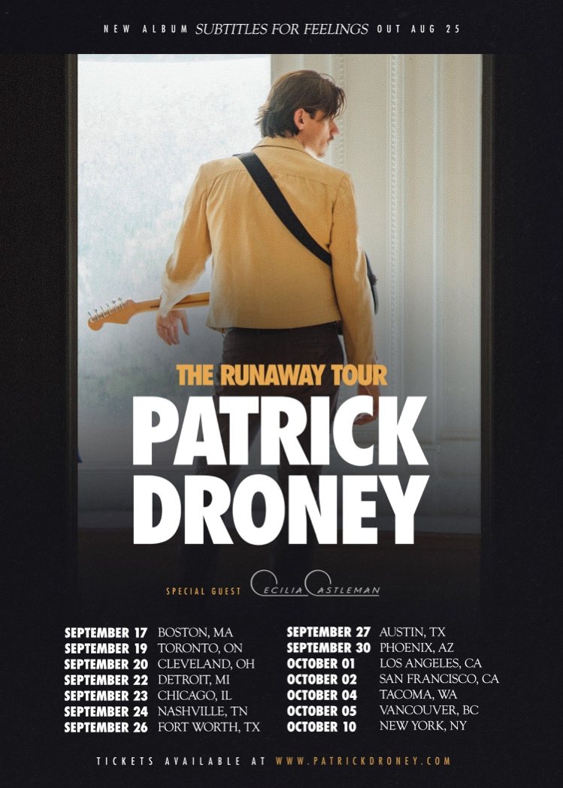

About Patrick Droney:
Patrick Droney grew up in the era of dedication lines and VHS tapes. He survives on sentimentality. It hits him every time he hears Delilah on the radio or passes by the Blockbuster sign near the bodega on his corner. The Brooklyn and Nashville based artist/producer/guitar sensation returns with his sophomore album, SUBTITLES FOR FEELINGS, which explores the idea that each frame of life holds a deeper context—a subtitle meant to be translated in time. Written and co-produced by Patrick Droney with collaborators including Foy Vance, Butch Walker, Jon Green, and Lori McKenna, the songs are a deepening of his timeless, cinematic pop sound. Rewind to May 2021, when Droney released his debut album, STATE OF THE HEART. With streams now in the hundreds of millions, the project was his own coming of age film, offering striking snapshots of the human condition in songs like “Glitter” and “The Wire.” Since then, he has toured extensively, selling out shows across the U.S. and making his U.K. debut with the Eagles at London’s Hyde Park. He performed at Super Bowl LVII, claims alumni status at Late Night With Seth Meyers, The Kelly Clarkson Show, and The Late Show with Stephen Colbert, and has shared stages with Sheryl Crow, The Vamps, and more. He also released genre-bending collaborations with Kygo (“Say You Will”) and Billy F. Gibbons (“Rough Boy”). Droney is set to bring the music on the road this fall with THE RUNAWAY TOUR 2023, which ends where his journey began—in New York at Webster Hall.

# # #
Contact Rick Gershon at Warner Records Publicity:
Rick.Gershon@warnerrecords.com

Follow Patrick Droney:
Official | Instagram | Twitter | Facebook | YouTube | Spotify | Press Materials

