24.1M Online
https://www.rollingstone.com/music/music-features/taylor-swift-cardi-b-rauw-alejandro-best-new-songs-1234784538/

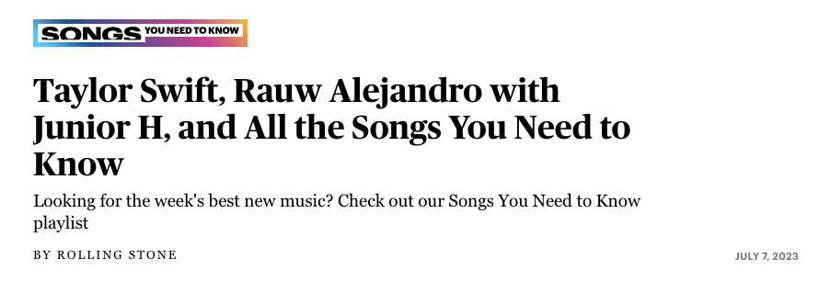
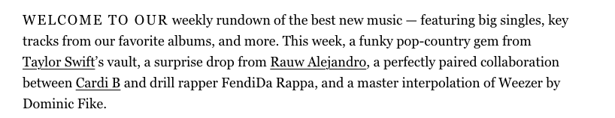
https://vmagazine.com/article/vs-new-music-roundup-taylor-swift-fifty-fifty-and-more/
