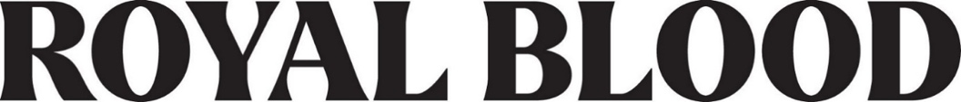

SHARE NEW SINGLE “PULL ME THROUGH”
LISTEN HERE / WATCH HERE

FROM THE NEW ALBUM BACK TO THE WATER BELOW
NEW RELEASE DATE SEPTEMBER 1
PRE-ORDER HERE

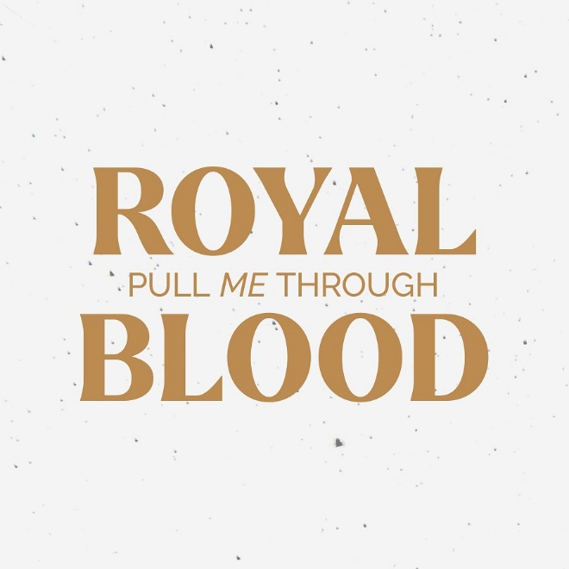
Hi-res download HERE

July 13, 2023 (Los Angeles, CA) — Today, Royal Blood unveil their new single “Pull Me Through” — listen HERE and watch the official video HERE. The track previews their eagerly anticipated fourth album Back To The Water Below, which follows on September 1, a week earlier than previously stated. “Pull Me Through” comes in the wake of breakout single “Mountains At Midnight.”

“Pull Me Through” is indicative of the broader palette of sounds that Royal Blood explore throughout Back To The Water Below. A step apart from anything they have previously released, the song builds upwards from its initial melancholic piano melody before erupting with a full-blooded denouement that ensures this stylistic shift is still resolutely Royal Blood. Themes of guilt and recrimination lurk ominously in Mike Kerr’s words, notably with the arresting lyric, “On a bed made of ‘What have you done?’”

Kerr says, “‘Pull Me Through’ is ultimately about giving up on persevering alone and finding strength in asking for help. It’s a song that is driven by the lyrics and melody, as opposed to the riffs doing the heavy lifting. Despite being piano led, it feels very much like a missing limb to our artillery and a track we’ve been eager to perform live.”

“Pull Me Through” comes with a visually arresting accompanying video with a powerful narrative directed by filmmaker and photographer Polocho via https://www.saygoodnightfilms.com. Watch it HERE.
As with the rest of Back To The Water Below, “Pull Me Through” was solely written and produced by Royal Blood.

Back To The Water Below is available to pre-order HERE. Remaining formats include signed black and deluxe marbled vinyl editions; signed CDs; and black and yellow cassettes, both of which feature alternate artwork.

The release of Back To The Water Below heralds a bold new chapter for Royal Blood. Their story is of two life-long friends, Mike Kerr (vocals, bass) and Ben Thatcher (drums), whose shared passion for rousing, full-throttle hard rock has led them on an extraordinary adventure together – a story of such success that it has yet to be repeated, leading to a succession of achievements that are as rare as they are remarkable. Moving from the pub circuit in their native Brighton to topping the UK album charts, winning the BRIT Award for Best British Group and garnering famous fans from Lars Ulrich to Jimmy Page. They’ve remained on a similar trajectory ever since, with their subsequent albums How Did We Get So Dark? and Typhoons both racing straight to #1 in the UK.

Royal Blood will kick off their North American headline tour in September. See HERE for ticket information and a list of all international dates.

North American Tour Dates:

Sep 16 Asbury Park, NJ Sea. Hear. Now Festival
Sep 18: Detroit, MI The Fillmore Detroit
Sep 19: Cleveland, OH Agora Theater
Sep 21 Louisville, KY Louder Than Life Festival
Sep 22: Saint Louis, MO The Pageant
Sep 23: Chicago, IL Riviera Theatre
Sep 25: Toronto, ON Queen Elizabeth Theatre
Sep 26: Montreal, QC MTELUS
Sep 27: Boston, MA Roadrunner
Sep 29: New Haven, CT College St. Music Hall
Sep 30: Philadelphia, PA The Fillmore

Oct 02: Brooklyn, NY Brooklyn Steel
Oct 03: New York, NY Webster Hall

Nov 09: Los Angeles, CA The Wiltern
Nov 10: Oakland, CA Fox Theater
Nov 11: Santa Cruz, CA The Catalyst
Nov 13: Seattle, WA Paramount Theatre
Nov 14: Vancouver, BC Queen Elizabeth Theatre
Nov 15: Portland, OR Crystal Ballroom
Nov 17: Salt Lake City, UT Union Event Center
Nov 18: Englewood, CO Gothic Theatre
Nov 20: Tulsa, OK Cain’s Ballroom
Nov 21: Dallas, TX South Side Ballroom
Nov 22: Austin, TX ACL Live at The Moody Theater
Nov 25: Albuquerque, NM Sunshine Theater
Nov 26: Phoenix, AZ The Van Buren
Nov 27: San Diego, CA The Sound

# # #

For more information, please contact:
National: Rick Gershon Rick.Gershon@warnerrecords.com
Regional: Delanee Wilson Delanee.wilson@warnerrecords.com

Follow Royal Blood:
Website | Spotify | Apple Music | YouTube | Facebook | Instagram | Twitter | TikTok | Press Materials

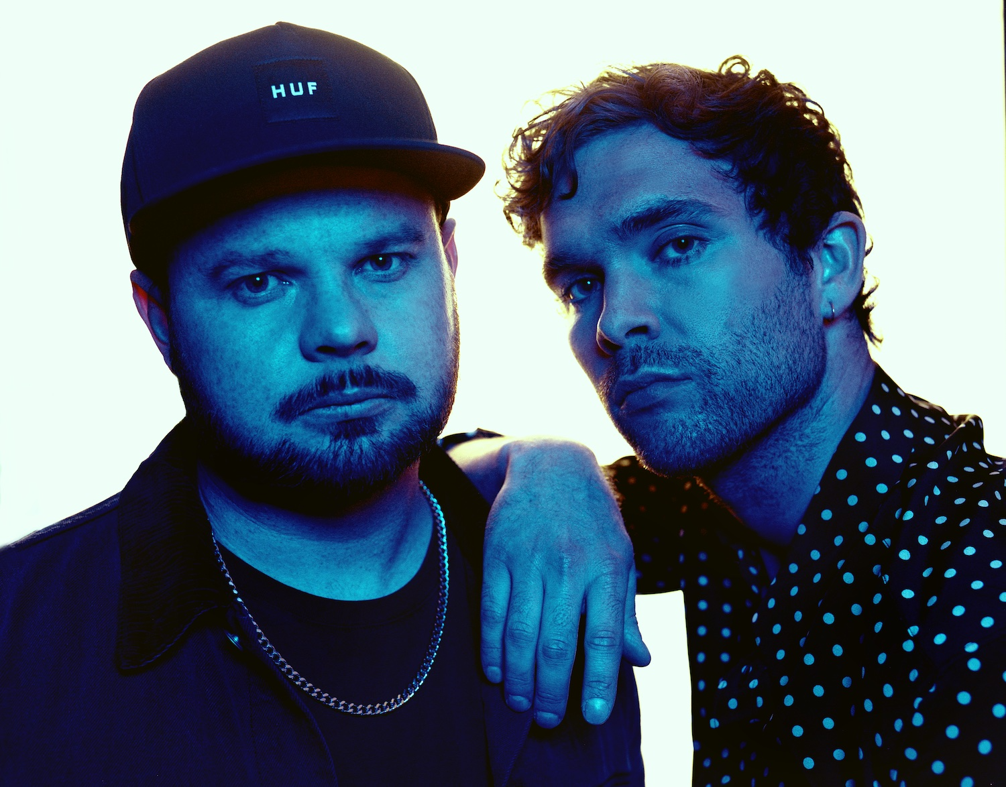
(Download high-res Royal Blood photo by Tom Beard HERE)

