RICKY MONTGOMERY IS OKAY WITH BEING A “BOY TOY” ON NEW SINGLE BUT KIND OF WANTS MORE…

LISTEN HERE | WATCH LYRIC VIDEO HERE

NEW ALBUM RICK OUT SEPTEMBER 29

“The listener can’t help but pay attention to Montgomery”
– Billboard

“Vibey bedroom pop-esque vulnerab[ility]… with the musician stepping into a more comfortable and mature sound”
– V Magazine

“better than ever, with a sharpened musical identity and narrative direction.”
– Wonderland Magazine

August 18, 2023 (Los Angeles, CA) – Heralding the release of his major label debut album, Rick – out September 29 – breakout alt-pop artist Ricky Montgomery shares an addicting new single “Boy Toy,” out now via Warner Records. With a punchy beat accelerated by a breezy guitar riff and a chorus that’s as cheeky as it is catchy as he promises, “I’ll be your boy toy…don’t need to tell me twice!” By the end, he essentially slips into acceptance of lust over love with this bouncy and bold anthem. Listen to “Boy Toy” HERE, pre-save Rick HERE, and pre-order physical formats of Rick HERE, including vinyl, CD, and cassette.

About the track, Ricky explains, “‘Boy Toy’ is, like many of my songs, telling two stories at once. On its surface, it's a song about being earnestly satisfied with being a booty call in the face of unrequited love. But beneath the lyrics, it's a reminder to myself to not need everything to be perfect. You don't always need to get everything you want.”

Working alongside GRAMMY-winning vets Dan Wilson and Jeremy Hatcher and GRAMMY-nominated producer Tommy English, Ricky’s forthcoming 14-track album is a soul-searching mix that balances sadness and doubt with lightness and levity. Its title alludes to Montgomery’s father, nicknamed Rick, a name he always assumed he’d eventually take on—“it seemed more ‘adult,’” he quips—but never had the nerve to.

“Rick is about my long, awkward path toward remembering myself as an artist. It’s been embarrassing and difficult, but also thrilling—kinda like changing your first name,” he says. “It’s everything I’ve ever wanted to do but was too scared to try.”

“Boy Toy” continues Ricky’s recent string of playful yet multi-layered and emotional singles “Don’t Say That” and “Eraser.” He most recently shared his emotionally charged “Black Fins” which recounts one of the most pivotal moments of Ricky’s life: his father’s 2009 suicide in Mexico, initially thought to be a scuba-diving accident until Ricky found hand-written letters.

Ahead of the forthcoming record, Ricky just concluded the Bittersweet Daze Tour this summer alongside close friends and collaborators Cavetown, mxmtoon, and grentperez. The special 12-date tour kicked off with a sold-out show at the Greek Theater, with $1 from every ticket sold benefiting Cavetown’s This Is Home Project.

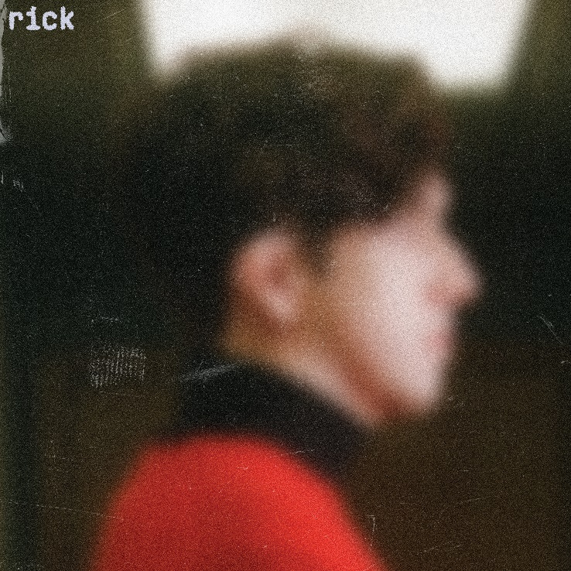
Hi-res press photos + artwork available here

‘RICK’ TRACKLISTING
- One Way Mirror
- Boy Toy
- Truth or Dare
- I’m Just Joking In This Interlude (Interlude)
- In Your Pocket
- Don’t Say That
- Eraser
- We Got Married Twice (Interlude)
- Type A
- Paper Towel
- Sometimes I Need To Be Alone
- Ethan’s Song
- Black Fins
- Ribbons (Outro)

ABOUT RICKY MONTGOMERY:
Music always lures Ricky Montgomery back. He blames the internet. First a devotee of the Vine underground, and now—nearly a decade and several jobs later—an unexpected hitmaker, the Los Angeles native has spent the last few years trying to reconcile with his artist self. He recently surpassed 1 billion global streams thanks to Platinum indie-pop hits “Mr. Loverman” and “Line Without a Hook.” But those songs, written when he was a teen, have come to feel like they were by a whole other person—at least to Ricky. In 2023, we get to meet Ricky’s new chapter, a sophomore set that comes seven years later, rich with electro-laced, emo-tinged alt-pop that spins stories about life in all its messy and mundane glory. Ricky's journey fits the bill: a childhood in L.A. interrupted by divorce, an adolescence playing in the basement bands of suburban Missouri, a viral explosion on a soon-to-implode platform, and a brief music career back on the West Coast that sent his songs up the Rock and Alternative charts. That was in 2014, before life intervened and he quit music for good… until the world discovered his sunny, sardonic songs. With millions of socials followers and a string of sold-out tours under his belt, Ricky now sets out to document "my long, awkward path toward remembering myself as an artist," he says. "It’s been embarrassing and difficult, but also thrilling. It’s everything I’ve ever wanted to do but was too scared to try.”

###

For more information, contact:
Ceri Roberts, Ceri.Roberts@warnerrecords.com
Patrice Compere, Patrice.Compere@warnerrecords.com

Press Materials:
press.warnerrecords.com/rickymontgomery

Follow Ricky Montgomery:
INSTAGRAM | TWITTER | YOUTUBE | TIKTOK

