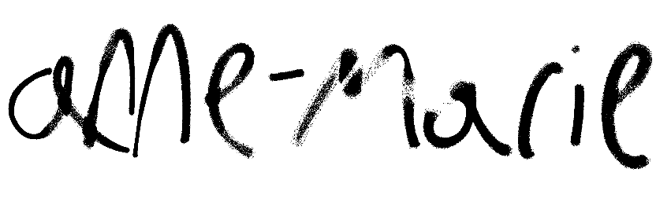
BRITISH POP SUPERSTAR ANNE-MARIE RELEASES
NEW ALBUM UNHEALTHY
LISTEN HERE

ALBUM FEATURES COLLABORATIONS WITH GLOBAL ICON
SHANIA TWAIN AND POP/R&B SUPERSTAR KHALID

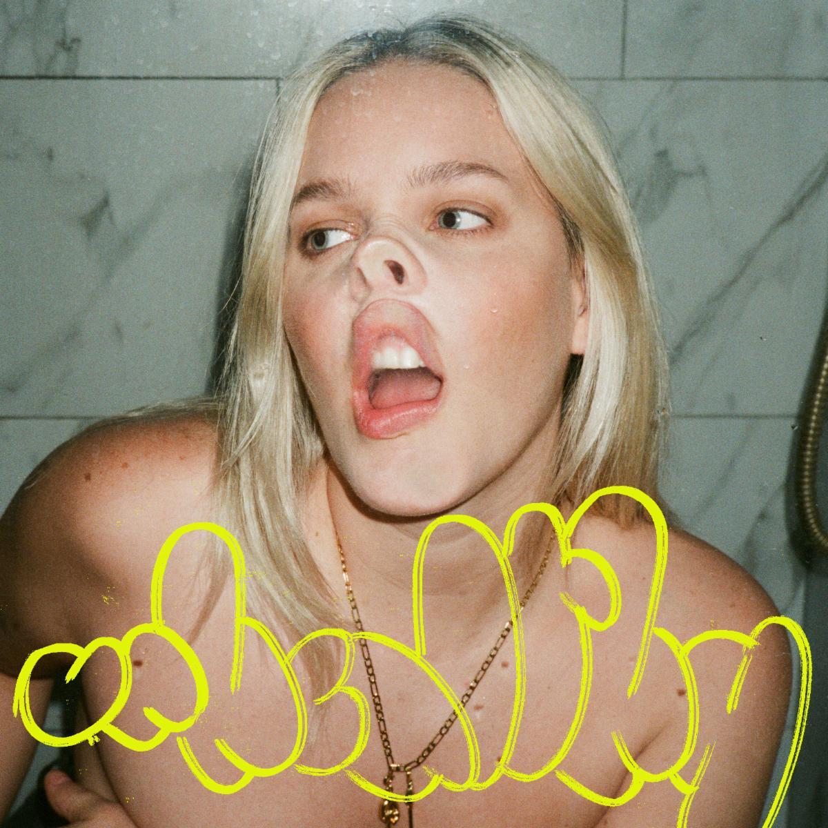
Download hi-res artwork HERE

July 28, 2023 (Los Angeles, CA) — Today, British pop star Anne-Marie releases her third studio album UNHEALTHY. Listen HERE.

Pulling from all parts of her life, Anne-Marie’s new album UNHEALTHY offers us a sneak peek into her perfectly imperfect world. Penned over a period when she felt ready to revisit and try to make sense of a host of raw past relationships—whilst also learning to process positive new ones—the new album takes us on a journey from chaos to contentment. This is Anne-Marie standing tall, embracing an all-new version of herself that’s fiercer, bolder, more chaotic, and blissfully happier than ever before.

The album features current single “UNHEALTHY”—the collaboration with global icon Shania Twain that arrived alongside a campy, western-inspired video—and emotional focus track “YOU & I” with pop/R&B superstar Khalid. Written and recorded alongside Kamille, The McDonough Brothers, Billen Ted, Evan Blair, and Nami, UNHEALTHY bridges topics of sadness, anger, joy, rebellion, and euphoria. The album’s thirteen tracks include gutsy empowerment anthems (“TRAINWRECK,” “GRUDGE”), tender, vulnerable streaks (“KILLS ME TO LOVE YOU,” “YOU & I”), guitar-fueled angst (“HAUNT YOU”) and musical theatre references—Anne-Marie starred in Les Misérables as a child—as she channels “I’d Do Anything” from Oliver! (“OBSESSED”).

UNHEALTHY TRACKLISITNG
- SUCKS TO BE YOU
- SAD B!TCH
- PSYCHO (FT. AITCH)
- HAUNT YOU
- TRAINWRECK
- GRUDGE
- OBSESSED
- KILLS ME TO LOVE YOU
- UNHEALTHY WITH SHANIA TWAIN
- IRISH GOODBYE
- CUCKOO
- YOU & I (FT. KHALID)
- NEVER LOVED ANYONE BEFORE

Follow Anne-Marie
Official | Instagram | Twitter | Facebook | YouTube | TikTok | Press Materials

For more information on Anne-Marie, please contact:
Darren Baber | Warner Records
Darren.Baber@warnerrecords.com

