GRAMMY-NOMINATED DJ/PRODUCER ILLENIUM ANNOUNCES SECOND TRILOGY: LOS ANGELES SHOW AT SOFI STADIUM

GENERAL ON-SALE FOR FEB 2 SHOW BEGINS AUGUST 16 AND NEWLY ADDED FEB 3 SHOW BEGINS AUGUST 18

FIFTH STUDIO ALBUM ILLENIUM OUT NOW

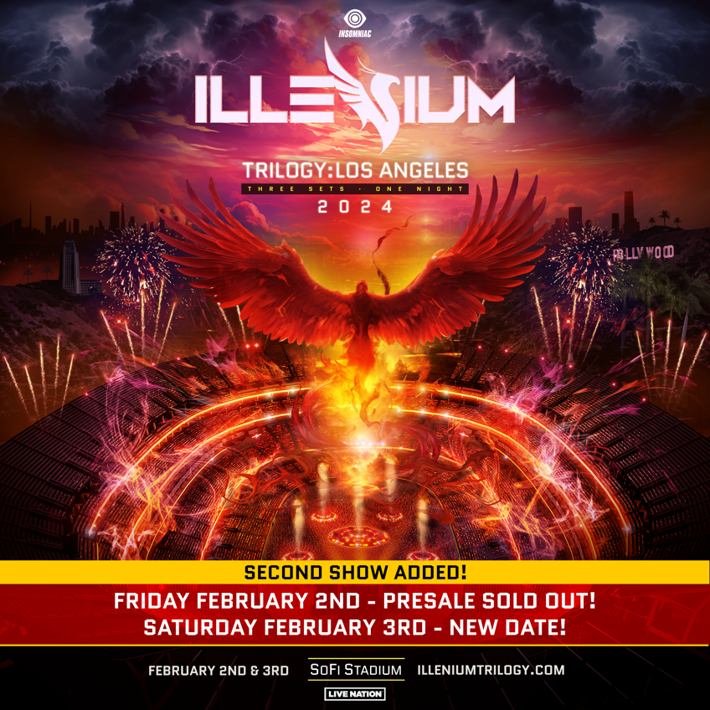

August 15th, 2023 (Los Angeles, CA) – Grammy-nominated DJ/producer ILLENIUM reveals the details for the third installment of his history-making Trilogy concert series, Trilogy: Los Angeles, which will take at SoFi Stadium on February 2, 2024 and a newly announced second show on Feb. 3, 2024.

Co-produced by Live Nation and Insomniac, it stands out as the first electronic dance music show at the venue since 2021. General on-sale for the Feb 2 show goes live on Wednesday August 16 at 10am local time on illeniumtrilogy.com. General on-sale follows for show on Feb 3 show on Friday August 18 at 10am local time.

ILLENIUM has transformed Trilogy into an institution in and of itself. A marathon 360-degreee sensory experience of immersive production, intense visuals, and three sets spanning his near decade-long career, it has exceeded one benchmark after another. Trilogy: Las Vegas descended upon Allegiant Stadium in 2021 and enshrined him as “the first EDM act to headline their own football stadium.” Moving to Denver for a massive homecoming in 2023, Trilogy: Colorado saw him headline, “the biggest, non-festival, EDM concert in North America ever.”

Of the latter, We Rave You attested, “He put on what is without a doubt, the greatest show of his career and arguably overall the single most iconic American electronic event in history.” Beyond features from The Denver Post and more, Billboard observed, “In recent years, he’s arisen as one of dance music’s most prominent, active and successful acts, playing — and selling out — some of the country’s largest stadiums and arenas,” and professed, “Illenium’s music forges deep bonds with listeners.”

Still, he ups the ante and raises the stakes yet again with Trilogy: Los Angeles. Don’t miss it!

This year, he unveiled his self-titled fifth full-length studio album, ILLENIUM (Warner Records). It arrived as his third consecutive #1 debut on the Billboard Top Dance/Electronic Albums Chart. A star-studded collection full of heart, soul, and cinematic beauty, the 16-track set includes the #1 dance hits “All That Really Matters” with Teddy Swims and “Luv Me A Little” with Nina Nesbitt. And that’s just the tip of the iceberg as he invites Avril Lavigne, Travis Barker, Vera Blue, All Time Low, JVKE, and more to kick things into even higher gear.

He supported the record with his biggest international headline run to date, ILLENIUM LIVE, selling out gigs across North America and touching down in Europe and Australia later this year. Tickets for all dates are on sale HERE. For the tour, he will also be partnering with the non-profit End Overdose, an organization close to his heart.

During 2022, he garnered a Grammy Award nomination in the category of “Best Dance/Electronic Music Album” and claimed the Billboard Music Award for “Top Dance/Electronic Music Album.” ILLENIUM has garnered mover the 8 billion global streams since the release of his 2016 debut LP Ashes and is undoubtedly one of the biggest names in dance music.

Stay tuned for more from ILLENIUM soon.

ILLENIUM LIVE Tour Dates:

EUROPE
Oct 11 – Barcelona, Spain @ Razzmatazz
Oct 13 – Milan, Italy @ Fabrique
Oct 14 – Warsaw, Poland @ Progresja
Oct 18 – Paris, France @ Elysée Montmartre
Oct 20 – Amsterdam, Netherlands @ MELKWEG
Oct 21 – Brussels, Belgium @ La Madeleine
Oct 26 – London, England @ Electric Brixton
Oct 27 – London, England @ Electric Brixton

AUSTRALIA
Nov 25 – Sydney, Australia @ Hordern Pavillion
Dec 1 – Melbourne, Australia @ John Cain Arena
Dec 2 – Brisbane, Australia @ The Fortitude Music Hall

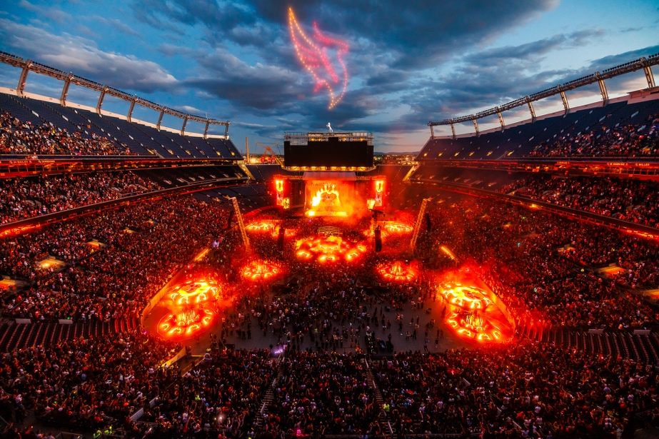
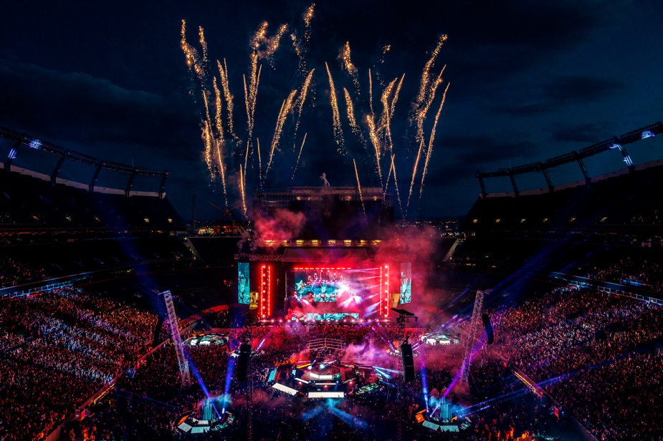
Live photos credit: RUKES
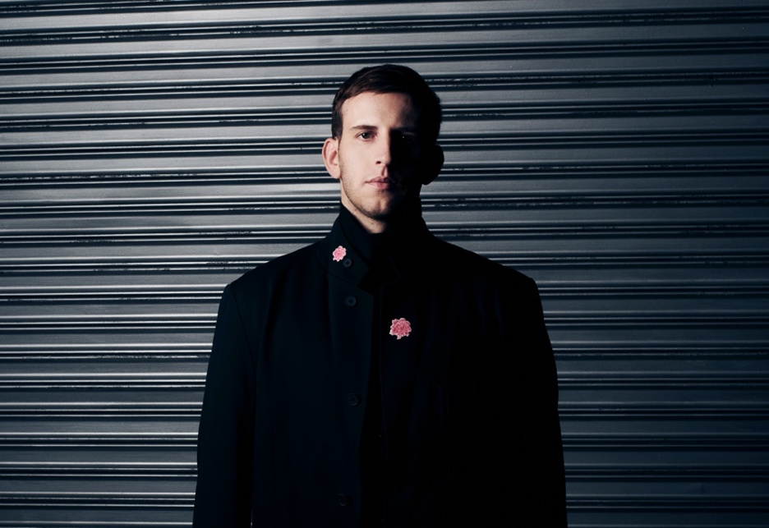
Credit: Lindsey Byrnes | Hi-Res Download HERE

FOLLOW ILLENIUM:
Website | Twitter | Instagram | Facebook | YouTube

For more information, please contact:
Darren Baber | Darren.Baber@warnerrecords.com

