GENRE-BLURRING ARTIST TEDDY SWIMS DROPS HIGHLY ANTICIPATED DEBUT ALBUM I’VE TRIED EVERYTHING BUT THERAPY (PART 1)
LISTEN HERE

INCLUDES POWERFUL NEW BALLAD “SOME THINGS I’LL NEVER KNOW” & BILLBOARD HOT 100 HIT "LOSE CONTROL"

PERFORMING LIVE ON THE TODAY SHOW THIS MORNING

NORTH AMERICAN HEADLINE TOUR KICKS OFF SEP 22

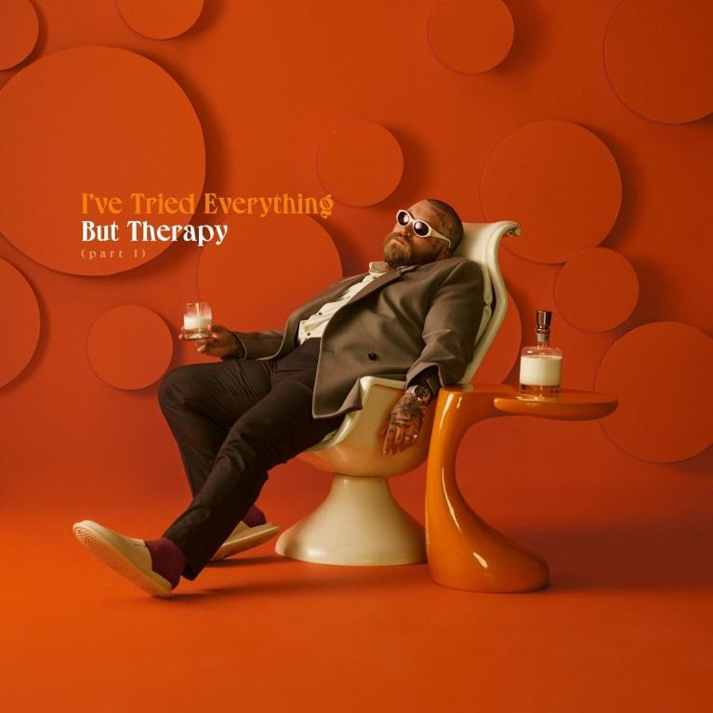
Download hi-res artwork HERE

September 15, 2023 (Los Angeles, CA) – Today, vocal powerhouse Teddy Swims releases his highly anticipated debut album I've Tried Everything But Therapy (Part 1). Listen HERE via Warner Records. Never one to pick a speed, the eclectic artist’s new body of work mixes pop, soul, funk, and blues to highlight his velvety rasp. Among the highlights is his new focus single “Some Things I’ll Never Know,” an intimate, gut-wrenching exploration of love and loss. Watch the video HERE.

About “Some Things I’ll Never Know,” Teddy says, “I’m the kind of person that wants to know I’ve turned over every stone and done absolutely everything I possibly could to keep someone in my life. But, sometimes you can’t control what people do or know why people do the things they do. Some relationships end without any closure and leave you with nothing but questions.”

Also included on the album is the viral sensation “Lose Control,” which recently became Teddy’s first-ever entry into the Billboard Hot 100, where it sits at #81 and climbing. To date, the track has amassed over 81 million streams and counting. Fans can watch him perform the song live on The Today Show this morning.

The album takes you on a ride with the intimate hymn “Last Communion,” followed by the rhythmically leaning “The Door,” an R&B anthem from another era. It's clear that Teddy is being more vulnerable than ever before on I've Tried Everything But Therapy (Part 1) — which is part of a longer journey of healing. "My debut album is an honest look into my mental health journey," Teddy says. "It is my first step towards being vulnerable about this journey and the steps I need to take to heal.”

The album follows 2022's Sleep is Exhausting and Tough Love EPs, which capped a busy year that included playing sold-out shows around the globe and lending his powerful pipes to ILLENIUM’s “All That Really Matters,” Meghan Trainor’s “Bad For Me,” and MK & Burns’ “Better.”

On September 22, Teddy will bring I've Tried Everything But Therapy (Part 1) to fans across the country as his North American tour kicks off in Minneapolis. It's destined to be one of the year's hottest tickets, given Teddy's renowned showmanship. He brings passion and poise to every performance, and now, with his album finally landing, an exciting new chapter begins for the southern singer. See the full list of tour dates below.

Teddy Swims 2023 Tour Dates:

Sep 22 Minneapolis, MN Palace Theatre
Sep 24 Chicago, IL Riviera Theatre
Sep 26 Richmond, VA The National
Sep 27 Norfolk, VA The NorVa
Sep 29 Raleigh, NC The Ritz
Sep 30 Greenville, SC Voyage Music Festival
Oct 1 Charlotte, NC The Fillmore Charlotte
Oct 3 Fort Lauderdale, FL Revolution Live
Oct 4 St. Petersburg, FL Jannus Live
Oct 5 Orlando, FL House of Blues Orlando
Oct 7 New Orleans, LA The Fillmore New Orleans
Oct 8 Houston, TX House of Blues Houston
Oct 10 Dallas, TX The Factory in Deep Ellum
Oct 11 San Antonio, TX Aztec Theatre
Oct 13 Wichita, KS TempleLive
Oct 14 Tulsa, OK Cain’s Ballroom
Oct 15 Oklahoma City, OK The Criterion
Oct 17 Phoenix, AZ The Van Buren
Oct 18 San Diego, CA SOMA – Mainstage
Oct 20 Los Angeles, CA The Wiltern
Oct 21 Las Vegas, NV Freemont Street Experience
Oct 22 Oakland, CA Fox Theater
Oct 24 Portland, OR Roseland Theater
Oct 25 Vancouver, BC Orpheum Theatre
Oct 26 Seattle, WA Showbox SoDo
Oct 28 Salt Lake City, UT Rockwell @ The Complex
Oct 29 Denver, CO Mission Ballroom
Oct 31 Omaha, NE The Admiral Theater
Nov 1 Kansas City, MO The Midland Theatre
Nov 3 Indianapolis, IN Egyptian Room at Old National Centre
Nov 4 Cincinnati, OH Bogart’s
Nov 5 Cleveland, OH Agora Theatre
Nov 7 Pittsburgh, PA Stage AE
Nov 8 Detroit, MI The Fillmore Detroit
Nov 10 Toronto, ON HISTORY
Nov 11 Montreal, QC Beanfield Theatre
Nov 12 Boston, MA Roadrunner
Nov 14 New York, NY Terminal 5
Nov 15 Philadelphia, PA The Fillmore Philadelphia
Nov 16 Washington, DC The Anthem
Nov 18 Nashville, TN Ryman Auditorium
Nov 21 Atlanta, GA Tabernacle
Nov 22 Atlanta, GA Tabernacle

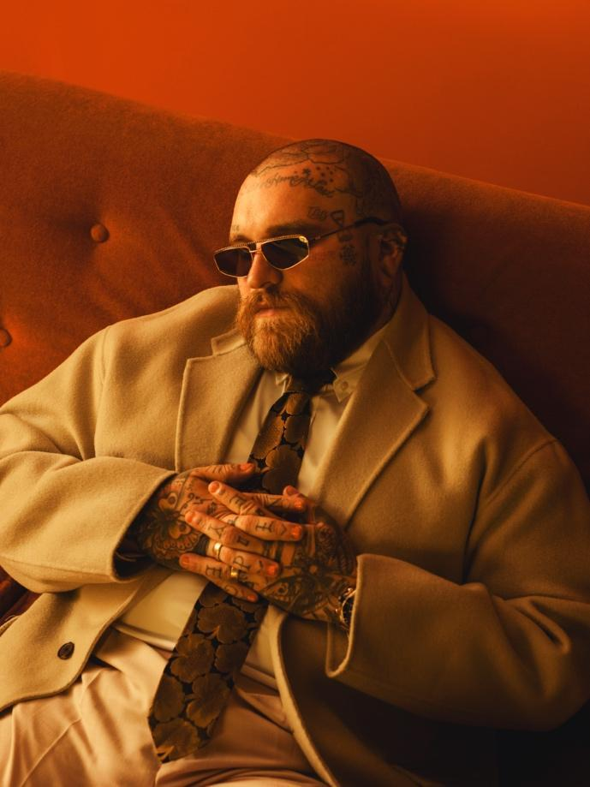
Download Hi-Res press photo HERE
Photo credit: Joseph Cultice

FOLLOW TEDDY SWIMS:
Official | Twitter | Instagram | TikTok | Facebook | YouTube | Press Materials

For more information, please contact:

Darren Baber | Warner Records
Darren.Baber@warnerrecords.com

Regional/Tour: Delanee Wilson | Warner Records
Delanee.Wilson@warnerrecords.com

