GLOBAL POP SENSATION GRIFF RELEASES NEW EP, VERT1GO VOL.1
FEATURING RECENT SINGLE “VERTIGO”
LISTEN HERE VIA WARNER RECORDS

Praise for “Vertigo”
“damn Griff I love this one” – Taylor Swift
“a cinematic and uplifting examination of what it means to
be a woman navigating your early twenties.” – V Magazine
“a pop slow-burner that tackles emotional turbulence head-on.” – UPROXX

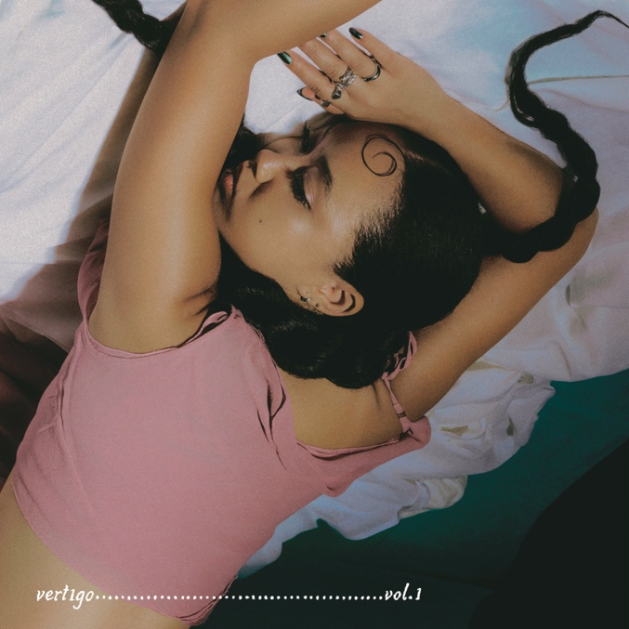
Download hi-res artwork HERE

October 20, 2023 (Los Angeles, CA) — Today, global pop sensation Griff shares her new three-song EP, vert1go vol.1. Listen HERE via Warner Records. The EP is an atmospheric, cinematic, and intimate set of songs from Griff.

The release was previewed by the fan-favorite lead single “Vertigo,” a rollercoaster of a record about feeling upside-down and the general disorientation of your early twenties. Entwined by the teething issues of young adulthood, vert1go vol.1 turns the tumultuousness of such times into a source of power. Focus track “Into The Walls” is powerfully nostalgic for the naivety of adolescence, while “19th Hour” chronicles a communication-breakdown with the observational style that’s always grounded Griff’s songwriting as mature beyond those formative, ‘Vertigo’-inducing years.

Griff is the multi-faceted modern pop star where normal rules need not apply. Born and raised outside of London, she started making music early in her teens. She realized at an early age — whether through her Chinese-Jamaican roots or her all-encompassing approach spanning songwriting, production, fashion, and design — that she was different. From day one, Griff’s learning curve has proved similarly sideways: she played just one gig prior to the pandemic in support of DIY EP Mirror Talk, with lockdown mixtape One Foot In Front of The Other rocketing Griff to pop stardom whilst stuck in her bedroom. The barrier-breaking project won Griff the prestigious BRITS Rising Star award and two NME Awards. To date, she has amassed over 660M streams in support of homemade hits like “Black Hole” and “Head on Fire.”

Finally unleashed from lockdown, Griff has since been invited to tour with some of the world’s biggest artists (Dua Lipa, Coldplay, Ed Sheeran, Florence + the Machine) and built an impassioned fanbase wherever her signature bubble-ponytail took her. It’s a back-to-front breakthrough that has also seen Griff play her first ever festivals — most recently, opening for HAIM at All Points East — and sell out shows on her own, like London’s landmark Brixton Academy.

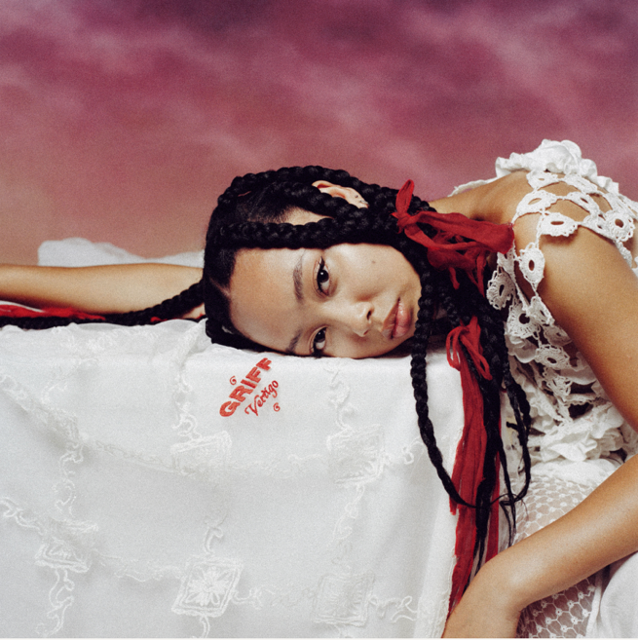
Download hi-res photo HERE

FOLLOW GRIFF:
Instagram | Twitter | Facebook | YouTube | TikTok | Press Materials

For more information, please contact:
Darren Baber | Warner Records
Darren.Baber@warnerrecords.com

