WARNER RECORDS’ WARREN ZEIDERS SHARES DEBUT ALBUM
PRETTY LITTLE POISON
LISTEN HERE

Title track surpassed 75 million global streams + recently entered the Top 25 of Billboard's Hot Country Songs Chart and Mediabase’s Country Airplay Top 40 Chart

Zeiders has amassed more than 1.2 billion global streams across his catalog

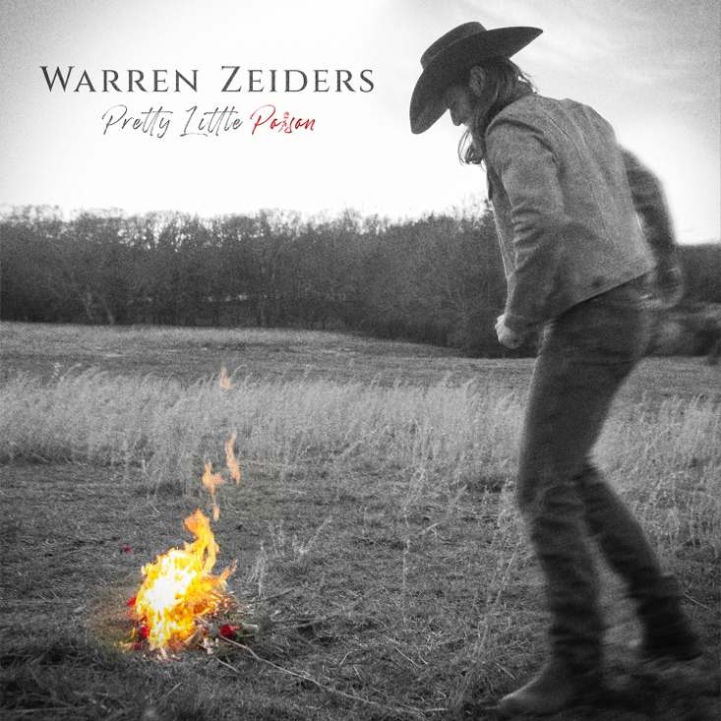
Download hi-res artwork HERE

August 18, 2023 (Los Angeles, CA) — Today, Warren Zeiders shares Pretty Little Poison, his debut album from Warner Records. Delivered on the heels of his 717 Tapes releases and compilation album — a collection of stripped-back singles and EP songs that introduced his powerhouse voice and sharp songwriting — Pretty Little Poison positions him as Nashville's newest headliner at just 24 years of age.

With an all-star list of collaborators, counting producers including GRAMMY-Award-winner Ross Copperman (Dierks Bentley, Old Dominion), Bart Butler (Cody Johnson, Jon Pardi) and Ryan Gore (Kelsea Ballerini, Midland), and co-writers including Chris Stapleton, Eric Paslay, Randy Montana, and more, the album is part road warrior, part old-fashioned grit, and a multitude of genre influences. These influences are apparent across the album’s 14 tracks — "God Only Knows" and "Coming Down High" are southern rock anthems built for summertime parties and backwoods joyrides, while songs like "Pain Killer" and "Love's A Leaving" explore the darkness of outlaw country. The bright choruses of "West Texas Weather" and "Some Whiskey" showcase his powerhouse vocals, while "Inside Your Head" — written by eight-time Grammy winner Stapleton — makes room for the lap steel guitars and timeless twang of classic country. For Zeiders, whose viral cover of "Tennessee Whiskey" played such a crucial role in his own rise to success, featuring a Stapleton cut on Pretty Little Poison feels a whole lot like fate.

The album’s lead single and title track — the cinematic “Pretty Little Poison” — debuted as “most added” on Country radio and recently broke into the Top 40 on the Mediabase Country Airplay Chart and the Top 25 of Billboard's Hot Country Songs Chart. The track — which Rolling Stone crowned one of The Best Country Songs of 2023 So Far — has already amassed more than 75M global streams since its spring release -- watch the official music video HERE.

Listen to Pretty Little Poison HERE

Watch the official video for “Some Whiskey” HERE

Zeiders has quickly risen from a college athlete to one of Nashville’s hottest stars at just 24 years old, amassing more than 1.2 billion global cumulative streams, 1.4 billion views on TikTok, and a combined 6 million social followers.

Pretty Little Poison Tracklist:
- “Pretty Little Poison” (Warren Zeiders, Jarred Keim, Ryan Beaver)
- “Some Whiskey” (Warren Zeiders, Randy Montana, Mark Hollman)
- “Love’s A Leavin'” (Warren Zeiders, Ross Copperman, Joy Beth Taylor)
- “Tell Me Like It Is” (Warren Zeider, Rivers Rutherford, Eric Paslay)
- “Black and Blue” (Warren Zeiders, Bart Butler, Joe Clemmons, Ryan Beaver)*
- “Weeping Willow” (Warren Zeiders, Randy Montana, Mark Hollman, Erik Dylan)*
- “Painkiller” (Warren Zeiders, Erik Dylan, Josh Phillips)*
- “Inside Your Head” (Chris Stapleton, Lee Thomas Miller)
- “Coming Down High” (Warren Zeiders, Bart Butler, Ryan Beaver, Benjy Davis)*
- “God Only Knows” (Warren Zeiders, Eric Paslay, Rob Crosby)
- “Drive You Crazy” (Warren Zeiders, Stephen Wilson Jr., Randy Montana)
- “West Texas Weather” (Warren Zeiders, Austin Taylor Smith)
- “Pittsburgh Steel” (Warren Zeiders, Randy Montana, Joe Fox )
- “Cowboys Ride Away” (Warren Zeiders, Ryan Beaver, Jared Keim)

*produced by Bart Butler & Ryan Gore
Note: all other songs produced by Ross Copperman

WARREN ZEIDERS UPCOMING TOUR DATES:
Aug. 18 - Jordan, NY - Kegs Canalside
Aug. 19 - Montreal, CA - Lasso 2023
Aug. 22 - Nashville, TN - Grand Ole Opry
Aug. 25 - Austin, TX - PBR Gambler Days
Aug. 26 - Louisville, KY - Kentucky State Fair
Aug. 31 - Dewey Beach, DE - Bottle & Cork
Sept. 1 - Philippi, WV - Barbour County Fair
Sept. 2 - Meshoppen, PA - Wyoming County Community Fair
Sept. 15 - Buffalo, NY - Town Ballroom
Sept. 16 - Pittsburgh, PA - Stage AE
Sept. 21 - Cleveland, OH - Agora Ballroom
Sept. 22 - Columbus, OH - KEMBA Live!
Sept. 23 - Harrisburg, PA - XL Live
Sept. 28 - Oklahoma City, OK - The Jones Assembly
Sept. 29 - Little Rock, AR - The Hall
Sept. 30 - New Orleans, LA - House of Blues New Orleans
Oct. 4 - Nashville, TN - Ryman Auditorium
Oct. 5 - Kansas City, MO - Uptown Theater
Oct. 6 - Tulsa, OK - Tulsa State Fair
Oct. 12 - Orlando, FL - House of Blues Orlando
Oct. 13 - North Myrtle Beach, SC - House of Blues Myrtle Beach
Oct. 14 - Charlotte, NC - The Fillmore Charlotte
Oct. 19 - Silver Spring, MD - The Fillmore Silver Spring
Oct. 20 - Raleigh, NC - The Ritz
Oct. 21 - Greenville, SC - Greenville Country Music Fest
Oct. 26 - Louisville, KY - Paristown
Oct. 27 - Indianapolis, IN - Egyptian Room at Old National Centre
Oct. 28 - Detroit, MI - The Fillmore Detroit
Nov. 2 - Saint Louis, MO - The Pageant
Nov. 3 - Omaha, NE - The Admiral Theatre
Nov. 4 - Minneapolis, MN - The Fillmore Minneapolis
Nov. 9 - Huntington, NY - The Paramount
Nov. 10 - Boston, MA - House of Blues Boston
Nov. 11 - Philadelphia, PA - The Fillmore Philadelphia

ABOUT WARREN ZEIDERS:
Warner Records artist Warren Zeiders is one of the genre’s fastest-rising success stories in recent history, leading People Magazine to observe “Warren Zeiders is a ‘Wild Horse’ who sings about "the truth.’” In 2022, his 717 Tapes: The Album notably collected all of Zeiders’ critically acclaimed 717 Tapes singles, EP tracks and a few new songs in a single package, including his recently released “Up To No Good” and “One Hell Of An Angel,” propelling him to the next chapter of his career and cementing the 717 Tapes legacy. He also made his Grand Ole Opry debut in the Summer of 2022—a rite of passage for the country's best and brightest. Zeiders – who has garnered more than 1.1 billion audio streams globally and 1.4 billion views on TikTok – recently received RIAA platinum certification for his breakthrough single, “Ride The Lightning," This Spring, he shared his Pretty Little Poison (Sampler) EP and extended his Pretty Little Poison headlining tour following his sold-out Spring run, which includes his first headlining show at Ryman Auditorium.

###

FOLLOW WARREN ZEIDERS:
Facebook | Instagram | Twitter | TikTok | YouTube

﻿PRESS CONTACTS:
Rick Gershon | Warner Records | rick.gershon@warnerrecords.com
Jaclyn D. Carter | Shore Fire Media | jcarter@shorefire.com
Andrea Evenson | Shore Fire Media | aevenson@shorefire.com
Maria Eilert | Shore Fire Media | meilert@shorefire.com

