CHER’S FIRST-EVER HOLIDAY ALBUM, CHRISTMAS AVAILABLE NOW!

Lead Single “DJ Play A Christmas Song” Heating Up Like A Yule Log, Listen HERE!

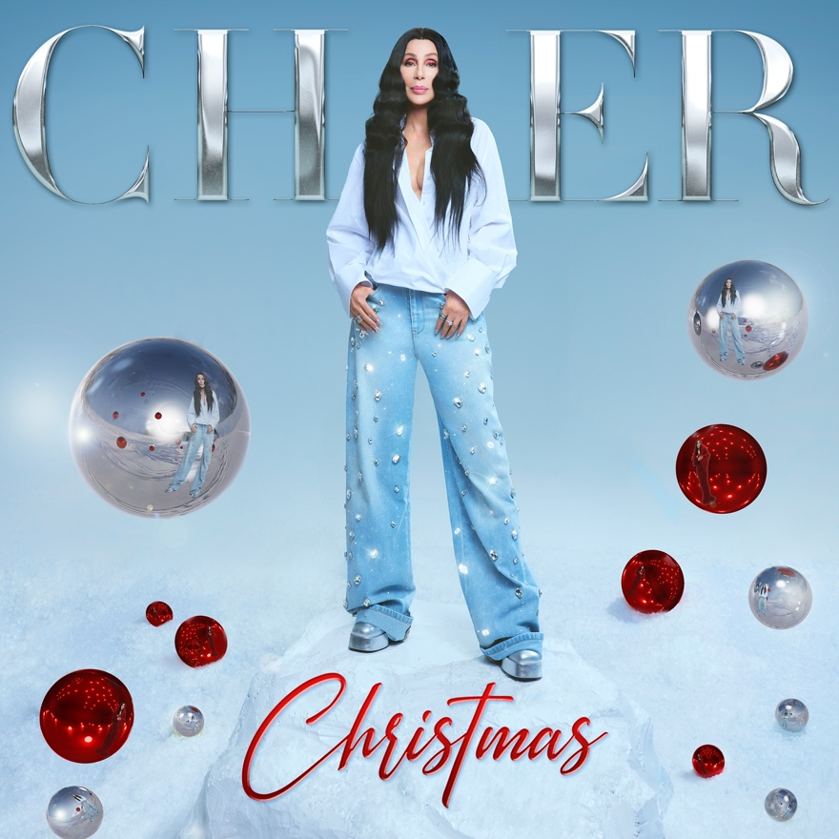
Download hi-res pics HERE

October 20, 2023 (Los Angeles, CA) - Cher has made our holiday wishes come true with the release of Cher Christmas – available now via Warner Records. Listen HERE.

Christmas, Cher’s first new studio album in five years, includes 13 songs - several holiday classics and four originals. It also has a star-studded list of musical besties including Darlene Love, Stevie Wonder, Michael Bublé, Cyndi Lauper and Tyga.

A full list of songs follows this release.

“I never say this about my own records but I’m really proud of this one. It is one of the most amazing highlights of my career,” commented Cher.

The Guardian raved, “The catchy dance track, ‘DJ Play a Christmas Song,’ evokes a night that’s anything but silent.” And Consequence added, “‘DJ Play a Christmas Song’ is a rebel’s anthem for anyone whose parents told them Santa Claus would skip their house if they didn’t go to sleep”

“DJ Play A Christmas Song," the first single, was written by Sarah Hudson (Dua Lipa, Katy Perry, Troye Sivan) and her team who contributed four new songs for the album. (Full Track listing below)

Recorded primarily in LA and London, Christmas was produced by longtime collaborator Mark Taylor (“Believe”). Songs include beloved superstar duet classics “What Christmas Means To Me" with Stevie Wonder and "Christmas (Baby Please Come Home)" with Darlene Love. (Darlene first recorded the song with Phil Spector and a l7-year-old Cher singing background vocals); in addition to a haunting version of “Home" written and sung with Michael Bublé.

One of the many highlights is a duet by Cher and Stevie Wonder of Stevie’s “What Christmas Means to Me." Commented Cher, “Every time I hear that harmonica, I’m a teenager again. It’s a personal dream come true for me to record this song with Stevie.”

Two other standouts include an unexpected pairing with Tyga on another Sarah Hudson song called “Drop Top Sleigh Ride” produced by Alexander Edwards, Mike Crook and Ryan OG, and the magnificent "Angels in the Snow" plus "Put A Little Holiday In Your Heart" with Cyndi Lauper.

Cher is also celebrating the 25th anniversary of her multi-platinum Grammy-winning "Believe” with the release of Believe 25th Anniversary (Deluxe Edition) on Warner Records.

CHER CHRISTMAS TRACK LIST:
1. DJ Play A Christmas Song
2. What Christmas Means To Me (with Stevie Wonder)
3. Run Run Rudolph
4. Christmas (Baby, Please Come Home) [with Darlene Love]
5. Angels In The Snow
6. Home (with Michael Bublé)
7. Drop Top Sleigh Ride (with Tyga)
8. Please Come Home For Christmas
9. I Like Christmas
10. Christmas Ain’t Christmas Without You
11. Santa Baby
12. Put A Little Holiday In Your Heart (with Cyndi Lauper)
13. This Will Be Our Year

Follow Cher:
Website | Twitter | Instagram | TikTok | Facebook | YouTube | Spotify | AppleMusic

For further information, please contact:

Liz Rosenberg // liz@lizrosenbergmedia.com

Laura Swanson // Laura.Swanson@warnerrecords.com

