MAX TURNS UP ON NEW SINGLE “SAY LESS” FEATURING DUCKWRTH LISTEN HERE | WATCH VIDEO HERE

NEW ALBUM LOVE IN STEREO ARRIVES FEBRUARY 16
PRE-ORDER/PRE-SAVE HERE

RELEASE WEEK SHOWS IN NEW YORK, CHICAGO, L.A.
*SOLD OUT*

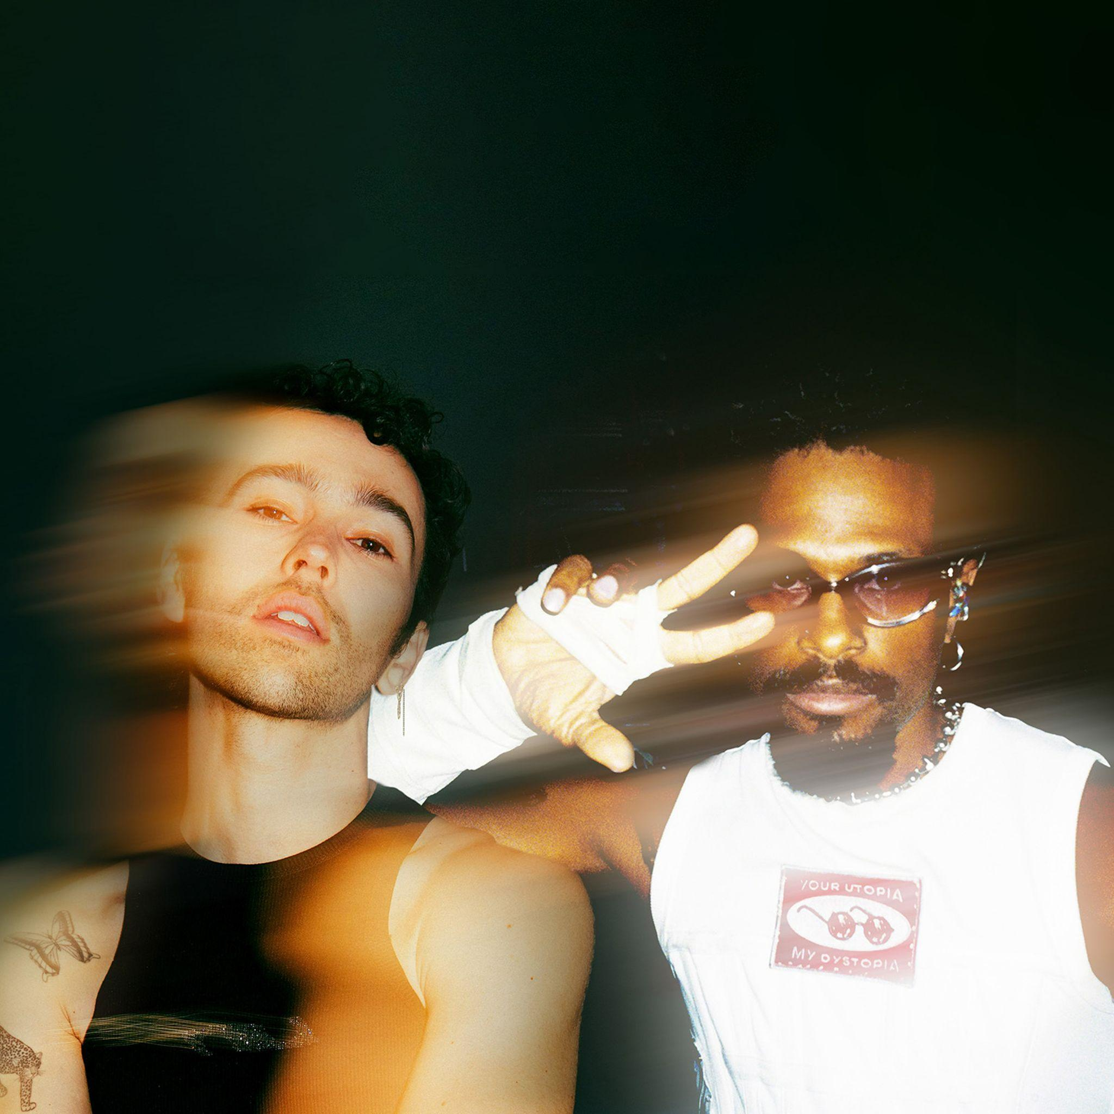
Download hi-res here

“Always authentic, MAX’s perspective on romance and partnership shines through his discography.”
– V Magazine

January 19, 2024 (Los Angeles, CA) – Today, genre-blurring pop artist MAX delivers another upbeat and undeniable anthem with “SAY LESS” [feat. Duckwrth]. Listen HERE and watch the video HERE. It heralds the arrival of his anxiously awaited new album, LOVE IN STEREO, out February 16 via Warner Records. Pre-order/Pre-save LOVE IN STEREO HERE.

MAX says, “‘SAY LESS’ is one of my favorite funky dance songs I’ve ever released, with the help of Mayer Hawthorne and the whole writing team. DUCKWRTH might have written some of the best bars on the whole album with his verse. I hope people everywhere dance as much as possible to this one."

MAX tunes into a myriad of emotions and sonic vibes across LOVE IN STEREO. The album boasts another new collaboration on “STUPID IN LOVE” featuring Huh Yun-jin of LE SSERAFIM - the track drops as the focus single with the album on February 16.

To celebrate the release of LOVE IN STEREO, MAX will perform three intimate shows in New York, Chicago, and Los Angeles. Tickets for all three dates have sold out, but you can keep an eye on any available tickets at www.maxmusicofficial.com.

He initially teased the record’s release with the heartfelt tribute to his daughter “EDIE CELINE.” LOVE IN STEREO also boasts signature anthems such as the platinum-certified "Butterflies" [feat. Ali Gatie], 100 million streamer “IT’S YOU” [feat. keshi], “GUCCI BAG,” “WASABI” and “STRINGS” [feat. JVKE & Bazzi], which cracked the Top 40 US pop radio. Check out the music video starring Dixie D’Amelio here! When MAX isn’t crafting pop sensations for himself, he often lends his talents to enormous artists. Most recently, he co-wrote BTS’s single “Yet To Come,” which hit #1 on the Billboard Ex-U.S. chart.

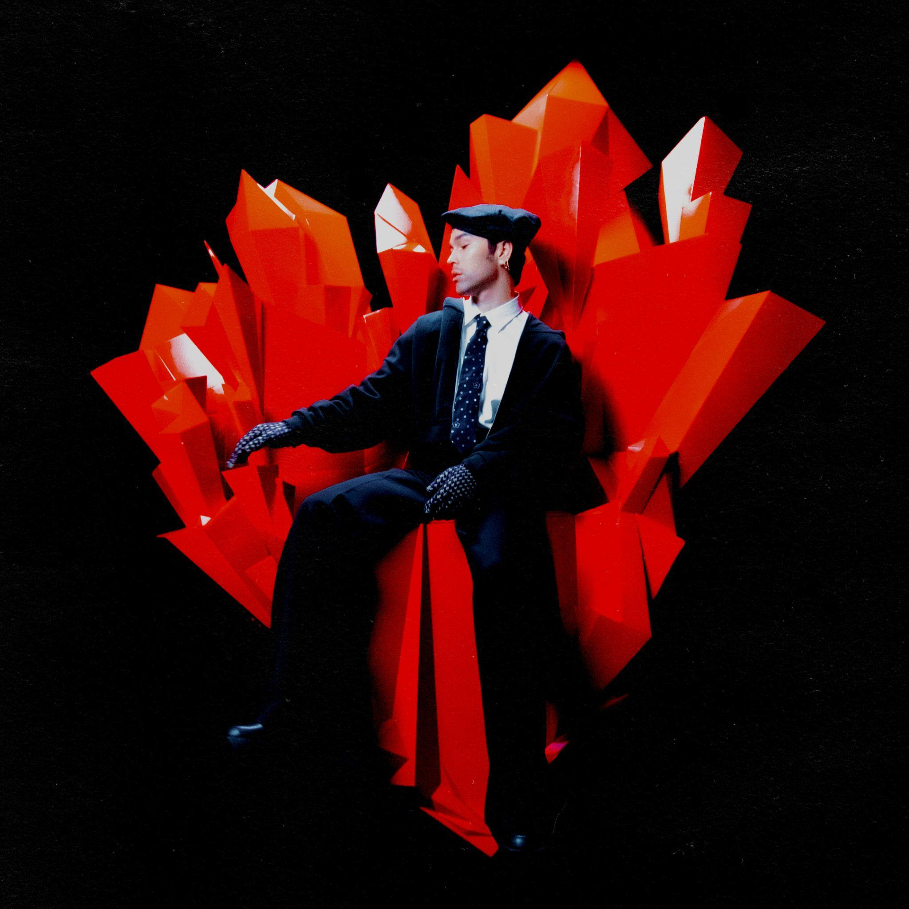
Download hi-res art here

LOVE IN STEREO TRACK LISTING:
- STUPID IN LOVE (feat. Huh Yun-jin of LE SSERAFIM)
- IT’S YOU (feat. keshi)
- SAY LESS (feat. Duckwrth)
- WOAH
- GUCCI BAG
- KEEP IT CHILL
- LOVE NEVER FELT LIKE THIS
- STRINGS (feat. JVKE & Bazzi)
- SUMMER ‘16
- WASABI
- BUTTERFLIES (feat. Ali Gatie)
- EDIE CELINE
U.S. ALBUM RELEASE SHOWS:
February 9 New York, NY - Bowery Ballroom *SOLD OUT*
February 13 Chicago, IL - Lincoln Hall *SOLD OUT*
February 19 Los Angeles, CA - The Troubadour *SOLD OUT*

ABOUT MAX:
MAX’s music is fueled by authenticity. From his unfiltered, heart-on-sleeve lyrics to his handcrafted visuals, the breakout pop star invites you to be part of his world, sharing the highs, lows, and every neon-hued emotion in-between. He’s been labeled a “young pop god” by GQ and dubbed a “top pop star to watch” by Billboard, and it’s no wonder: He broke through in 2016 with the ubiquitous, triple-platinum “Lights Down Low.” The track shot to #1 at Hot AC radio and went platinum in a number of countries. Since then, MAX has amassed more than 1.5 billion streams, released a number of other multi-platinum songs, dropped the pop-expanding Colour Visions album, and collaborated with everyone from Suga of BTS to Chromeo and Hayley Kiyoko to keshi. Now, as he continues a new chapter with LOVE IN STEREO, MAX will propel his heartfelt and authentic vision further than ever before.

FOLLOW MAX:
Website | Facebook | Twitter | Instagram | YouTube | TikTok

For more information, please contact:
Ceri Roberts / Warner Records
ceri.roberts@warnerrecords.com

Patrice Compere / Warner Records
patrice.compere@warnerrecords.com

