MAX DROPS LOVEDRUNK NEW SINGLE “STUPID IN LOVE”
FEATURING HUH YUNJIN OF LE SSERAFIM
LISTEN HERE | WATCH LYRIC VIDEO HERE

NEW ALBUM LOVE IN STEREO OUT NEXT WEEK ON FEBRUARY 16
PRE-ORDER/PRE-SAVE HERE

RELEASE WEEK SHOWS IN NEW YORK, CHICAGO, L.A.
*SOLD OUT*

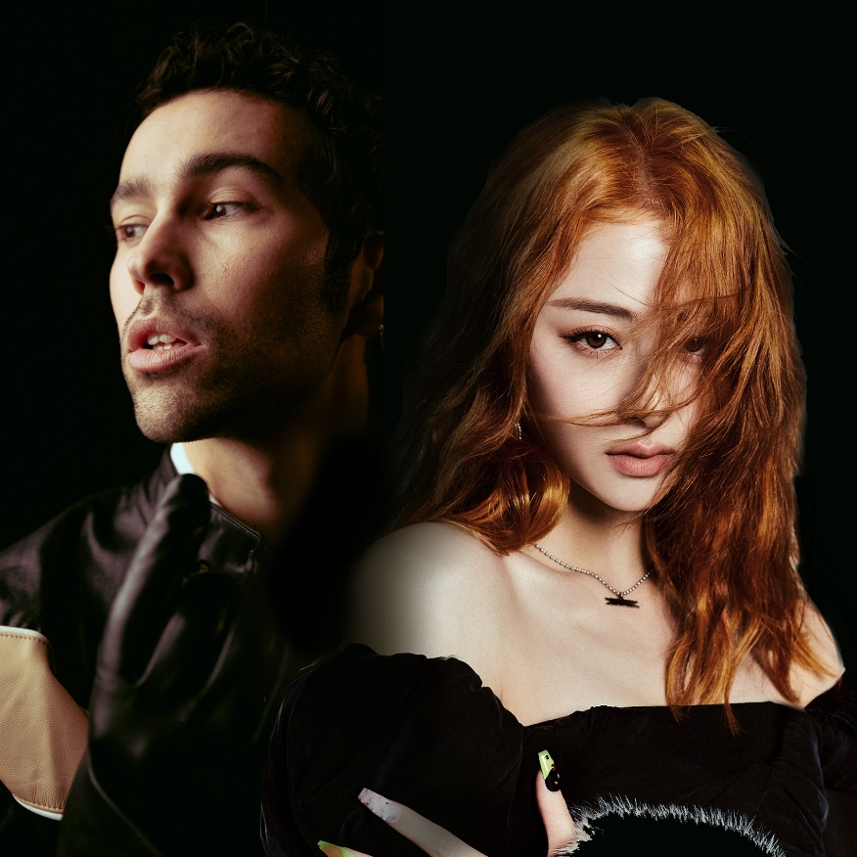

“Always authentic, MAX’s perspective on romance and partnership shines through his discography.”
– V Magazine

February 9, 2024 (Los Angeles, CA) – Gearing up for Valentine’s Day next week, genre-blurring pop artist MAX shares an irresistible new single entitled “STUPID LOVE” featuring HUH YUNJIN of K-Pop girl group phenomenon LE SSERAFIM. Listen HERE and watch the lyric video HERE. It only increases anticipation for the arrival of his highly-anticipated new album, LOVE IN STEREO, out February 16 via Warner Records. Pre-order/Pre-save LOVE IN STEREO HERE.

In recent years, MAX has captivated fans worldwide alongside K-Pop superstars, co-writing BTS’ single “Yet To Come” and collaborating with SUGA of BTS on “Blueberry Eyes” and Agust D on the mixtape D-2.
“STUPID IN LOVE” arrives on the heels of “SAY LESS” [feat. Duckwrth], plus the heartfelt tribute to his daughter “EDIE CELINE,” the platinum-certified "Butterflies" [feat. Ali Gatie], 100 million streamer “IT’S YOU” [feat. keshi], “GUCCI BAG,” “WASABI” and “STRINGS” [feat. JVKE & Bazzi], which cracked the Top 40 US pop radio. Check out the music video starring Dixie D’Amelio here, and see a full track listing for LOVE IN STEREO below.

To celebrate the release of LOVE IN STEREO, MAX will perform three intimate shows in New York, Chicago, and Los Angeles. Tickets for all three dates have sold out, but you can keep an eye on any available tickets at www.maxmusicofficial.com.

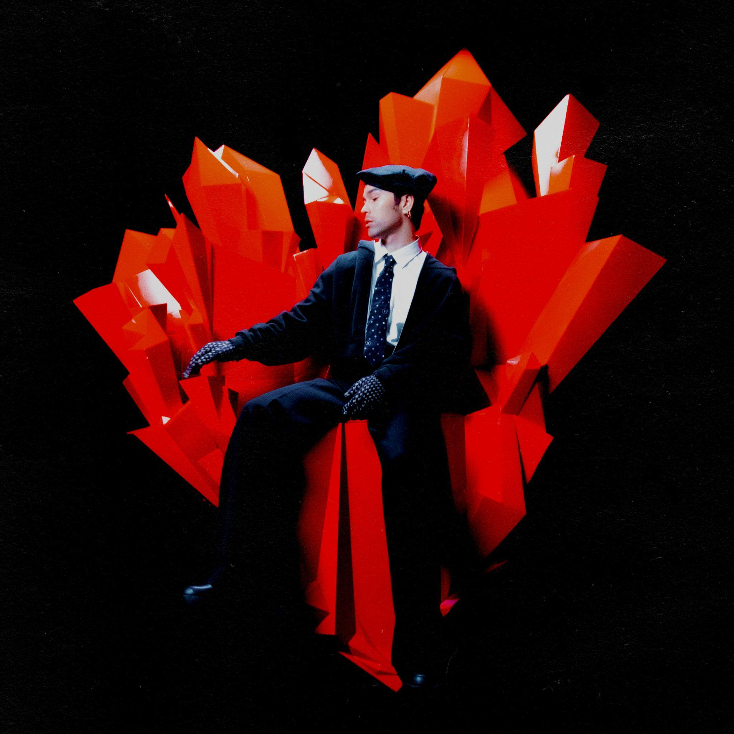
Download hi-res art here

LOVE IN STEREO TRACK LISTING:
- STUPID IN LOVE (feat. Huh Yun-jin of LE SSERAFIM)
- IT’S YOU (feat. keshi)
- SAY LESS (feat. Duckwrth)
- WOAH
- GUCCI BAG
- KEEP IT CHILL
- LOVE NEVER FELT LIKE THIS
- STRINGS (feat. JVKE & Bazzi)
- SUMMER ‘16
- WASABI
- BUTTERFLIES (feat. Ali Gatie)
- EDIE CELINE
U.S. ALBUM RELEASE SHOWS:
February 9 New York, NY - Bowery Ballroom *SOLD OUT*
February 13 Chicago, IL - Lincoln Hall *SOLD OUT*
February 19 Los Angeles, CA - The Troubadour *SOLD OUT*

ABOUT MAX:
MAX’s music is fueled by authenticity. From his unfiltered, heart-on-sleeve lyrics to his handcrafted visuals, the breakout pop star invites you to be part of his world, sharing the highs, lows, and every neon-hued emotion in-between. He’s been labeled a “young pop god” by GQ and dubbed a “top pop star to watch” by Billboard, and it’s no wonder: He broke through in 2016 with the ubiquitous, triple-platinum “Lights Down Low.” The track shot to #1 at Hot AC radio and went platinum in a number of countries. Since then, MAX has amassed more than 1.5 billion streams, released a number of other multi-platinum songs, dropped the pop-expanding Colour Visions album, and collaborated with everyone from Suga of BTS to Chromeo and Hayley Kiyoko to keshi. Now, as he continues a new chapter with LOVE IN STEREO, MAX will propel his heartfelt and authentic vision further than ever before.

FOLLOW MAX:
Website | Facebook | Twitter | Instagram | YouTube | TikTok

For more information, please contact:
Ceri Roberts / Warner Records
ceri.roberts@warnerrecords.com

Patrice Compere / Warner Records
patrice.compere@warnerrecords.com

