ICONIC BRITISH DUO PET SHOP BOYS RETURN WITH BRAND
NEW SINGLE “LONELINESS” - WATCH HERE

ANNOUNCE RETURN TO PARLOPHONE RECORDS WITH UPCOMING STUDIO ALBUM NONETHELESS OUT APRIL 26

PET SHOP BOYS DREAMWORLD: THE GREATEST HITS LIVE AT THE ROYAL ARENA COPENHAGEN DEBUTS IN CINEMAS WORLDWIDE
TONIGHT & FEBRUARY 4TH

APRIL ALSO MARKS THE 40TH ANNIVERSARY OF CLASSIC
#1 HIT “WEST END GIRLS”

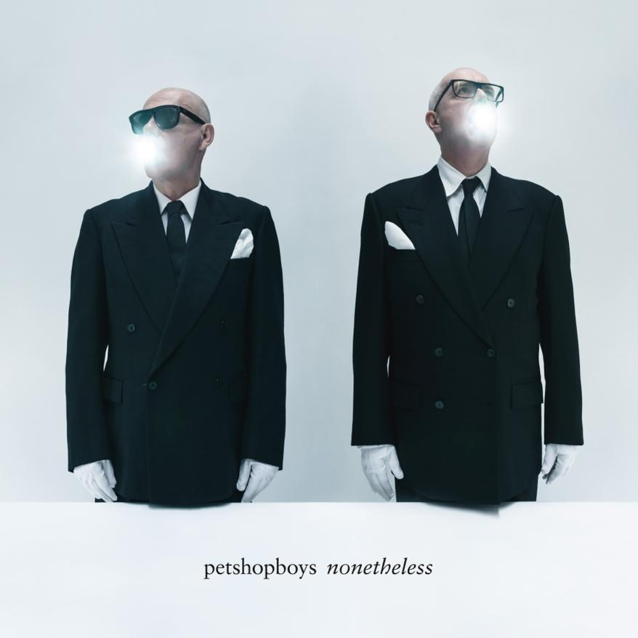
Download high-res artwork HERE

January 31, 2024 (Los Angeles, CA) — Iconic British duo Pet Shop Boys kick off 2024 with brand new uplifting and reflective single “Loneliness,” out today via Parlophone. They also announce their upcoming 15th studio album Nonetheless, arriving April 26. Listen to “Loneliness” HERE and pre-order Nonetheless HERE. Watch the “Loneliness” video, which was directed by renowned photographer/director Alasdair McLellan, HERE.

The announcement also marks their return to Parlophone Records, the label which released their iconic and massively successful material spanning from 1985 to 2012. The album is the duo’s first with producer James Ford, who has previously worked with artists including Arctic Monkeys, Depeche Mode, Blur, Gorillaz and Simian Mobile Disco.

In a special cinema release in partnership with Trafalgar Releasing, Pet Shop Boys Dreamworld: The Greatest Hits Live at the Royal Arena Copenhagen is coming to screens worldwide for an exclusive two-night event later today (Jan 31) and Sunday February 4, showcasing Pet Shop Boys' electrifying tour captured at the Royal Arena in Copenhagen last summer. Tickets are available now via psbdreamworldlivefilm.com.

This year marks the 40th anniversary of their classic debut single “West End Girls,” which was their first global #1. They will celebrate with five special performances at London’s Royal Opera House from July 23 to 27. In 2016, they became the first electronic group to play the venue, and returned for additional sold-out shows in 2018. Fans who pre-order the album at http://www.petshopboys.co.uk will receive access to priority tickets for the shows.

Notably energized and driven by the huge resurgence spawned by their last trilogy of studio albums and the ongoing success of their Dreamworld: The Greatest Hits Live tour, Nonetheless features 10 brand new tracks, recorded and mixed in London last year. The music is both uplifting and reflective, mixing electronics, live instruments and orchestral arrangements.

Pet Shop Boys spoke about the creative process around the record:

“We wanted this album to be a celebration of the unique and diverse emotions that make us human. From the more dance-orientated tracks to the raw poignancy of the introspective ballads, with their beautiful string arrangements, each track tells a story and contributes to the overall narrative of the album.”

“It was great to work with James Ford, who we think has brought new elements to our music. James has dared to make us a bit more minimal at times and the final result is a record we’re very proud of.”

ABOUT PET SHOP BOYS:
Having sold in excess of 50 million records, Pet Shop Boys are easily the most successful UK duo of all time. Since their first #1 single, “West End Girls,” they have forged a singular path. Such is the strength of their catalogue that in June 2020, The Guardian reported that “West End Girls” had been voted the greatest #1 single ever in the UK: “36 years on, their debut single still pulses with that beguiling ambiguity - perfect pop equilibrium that almost made Dusty Springfield crash her car the first time she heard it.”

BRIT Awards and Grammy nominations have been numerous, including in 2009 when Pet Shop Boys won the BRIT for Outstanding Contribution to Music; in 2000 Pet Shop Boys’ song-writing was rewarded with the Ivor Novello award for Outstanding Contribution to British Music - with over 70 hit singles spanning five decades, song-writing remains resolutely at the core of Pet Shop Boys’ continuing relevance and success.

Their last three albums, recorded with producer Stuart Price, coincided with extended bouts of touring which saw the group headline Glastonbury for the third time, as well as headlining other major music festivals across the world. The duo also toured the US in 2022 in the co-headlining Unity tour with New Order, which saw them selling out arenas including Madison Square Garden in New York and the Hollywood Bowl in LA. More dates for the Dreamworld tour have already been announced for 2024, including a headline slot at the Isle of Wight Festival this summer.

Nonetheless tracklisting:

LONELINESS
FEEL
WHY AM I DANCING?
NEW LONDON BOY
DANCING STAR
A NEW BOHEMIA
THE SCHLAGER HIT PARADE
THE SECRET OF HAPPINESS
BULLET FOR NARCISSUS
LOVE IS THE LAW

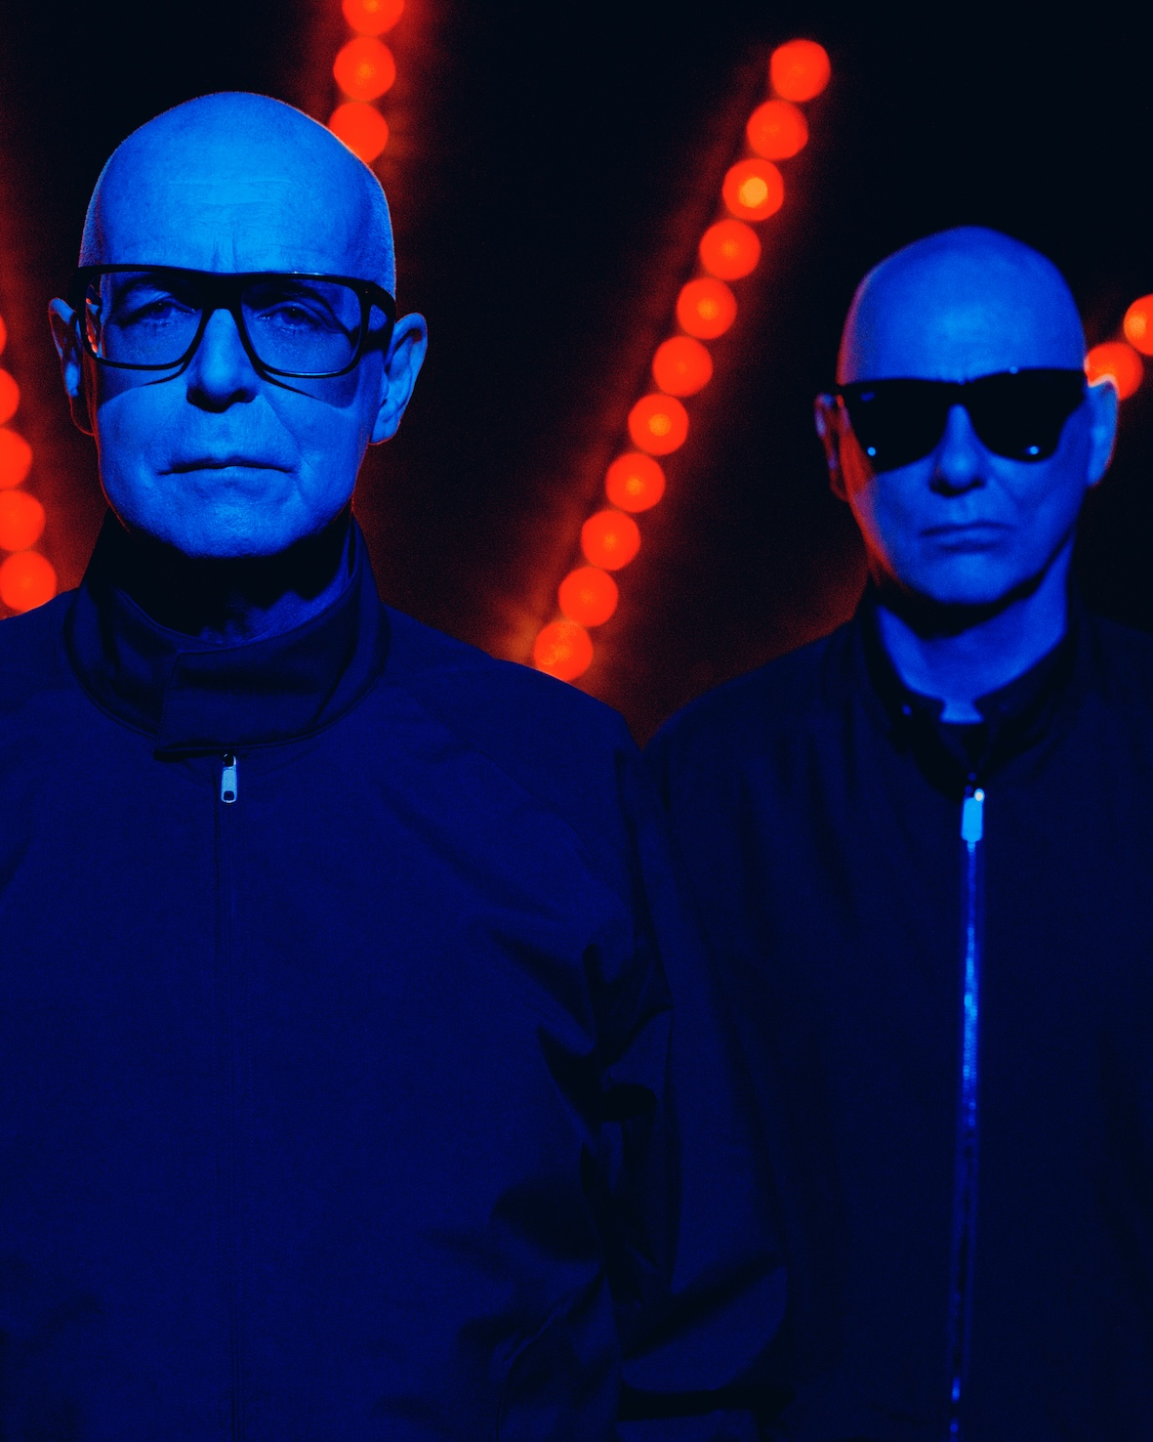
Credit: Alasdair McLellan
Download hi-res HERE

petshopboys.co.uk
For more information, please contact:
Laura Swanson | Warner Records
Laura.Swanson@warnerrecords.com

Darren Baber | Warner Records
Darren.Baber@warnerrecords.com

