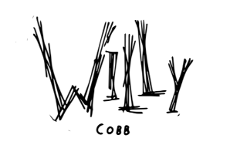
SOUTHERN ALT ROCKER WILLY COBB DROPS DEBUT SINGLE “CIGARETTE SMELL”

LISTEN HERE

SIGNS TO WAR BUDDHA / WARNER RECORDS

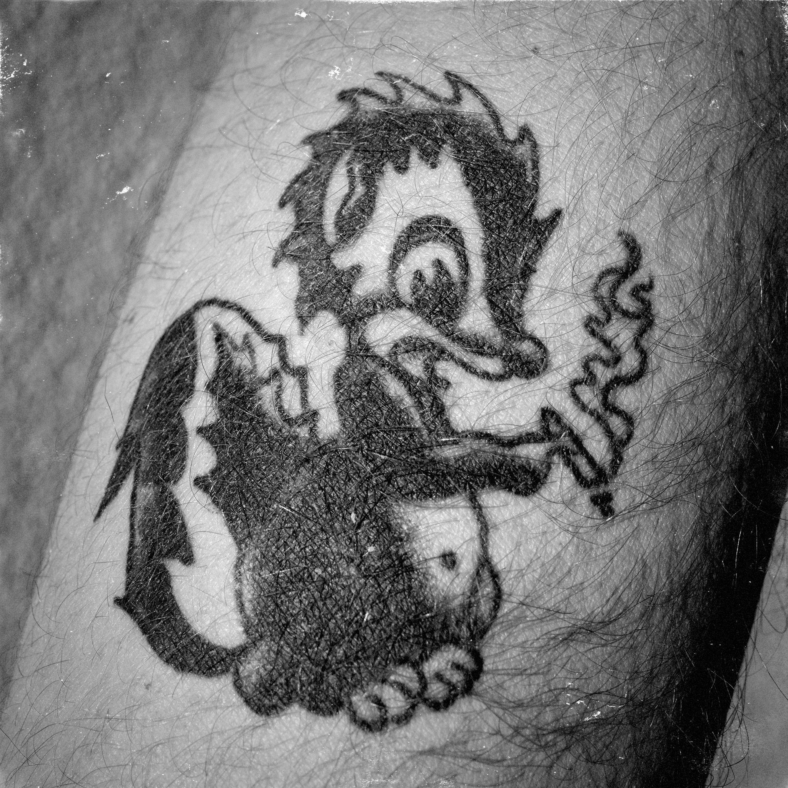
Credit: Alex Berger

Los Angeles, CA (March 15, 2024) – Today, Southern alt rocker Willy Cobb lights up his new single “Cigarette Smell.” It marks the genre-busting artist’s official debut under his newly minted deal with War Buddha / Warner Records. Listen to “Cigarette Smell” HERE.

“Cigarette Smell” is a potent and endlessly replayable introduction to Cobb’s unpretentious style, evincing his infectious combination of irreverence and specificity. He sticks to crisp, suitably absurd imagery all the way through the power chorus: “I bet you hate the way cigarettes smell/I bet you vape all day cause it’s better for ya health.” Channeling White Stripes in their lo-fi era, the track exemplifies the disarming, immediately personable quality that has made Cobb a live phenomenon in Nashville.

Following European and UK tour dates with Chris Shiflett of Foo Fighters and The Cadillac Three, the Georgia-reared musician is set to join the latter for a string of North American shows this Spring. He hits the road on April 6 in Jackson, TN before rolling across the Midwest and concluding on April 20 in Columbia, MO. Check out the full confirmed itinerary below.

“Cigarette Smell” is just the beginning. Stay tuned for a whole lot more from Willy Cobb this year.

About Willy Cobb:

Alternative rock singer-songwriter Willy Cobb’s new music, produced and co-written with country singer Brent Cobb and The Cadillac Three leader Jaren Johnston, serves as a dynamic crash course in his blend of down-home pride and punk attitude. As a kid riding in his family’s truck, his dad would throw on Hank Williams, while his mom favored Nirvana. Now a rising talent in Nashville, the singer and guitarist still channels his upbringing in his lyrics, which pay homage to small-town misbehavior and malaise.

Not caring what people think is a crucial aspect of Cobb’s view of himself and his music. While he credits other like-minded Southern artists who flout easy genre labels, Cobb considers himself to be on a unique mission to connect with fans who might feel like outsiders in their communities. “There’s a whole minority of kids in the South that feel like me—that were weird and alternative in high school,” Cobb explains. “I want them to see that you don’t have to be country to be from Georgia.”

WILLY COBB TOUR DATES:
3/20 Dublin, Ireland The Academy*
3/21 Belfast, UK Limelight*
3/23 Glasgow, UK Queen Margaret Union*
3/24 Manchester, UK Manchester Academy*
3/25 Birmingham, UK O2 Academy Birmingham*
3/27 Camden, UK Electric Ballroom*
4/6 Jackson, TN Hub City Brewing^
4/11 Springfield, MO Midnight Rodeo^
4/12 Springfield, IL Boondocks^
4/13 Flint, MI The Machine Shop^
4/20 Columbia, MO Rose Park^
5/4 Dublin, Ireland The Academy+
5/5 Belfast, UK Limelight+
5/8 Glasgow, UK O2 Academy+
5/9 Newcastle Upon Tyne, UK NX Newcastle+
5/11 Manchester, UK Manchester Academy+
5/12 Leeds, UK O2 Leeds Academy+
5/14 Nottingham, UK Rock City+
5/16 Cardiff, UK Tramshed+

*Supporting Chris Shiflett
^Supporting The Cadillac Three
+Supporting The Cadillac Three, Stephen Wilson Jr.

Follow Willy Cobb:
Instagram | TikTok | YouTube | Website | Press Assets

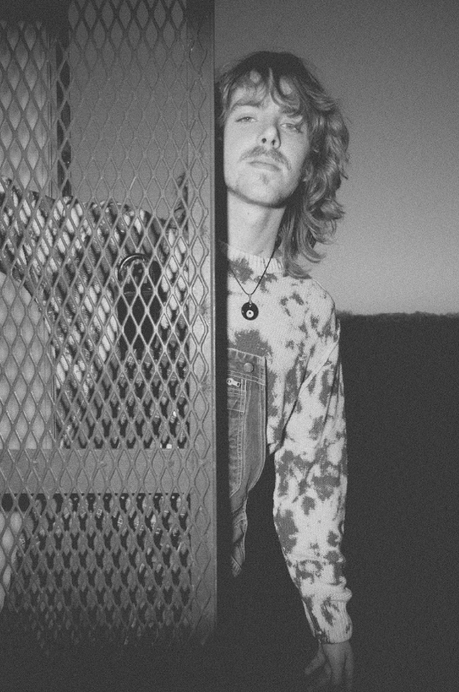
Credit: Alex Berger

Warner Records:
Connor Hunt // Connor.Hunt@warnerrecords.com

Delanee Wilson // Delanee.Wilson@warnerrecords.com

