MEDIA ALERT:
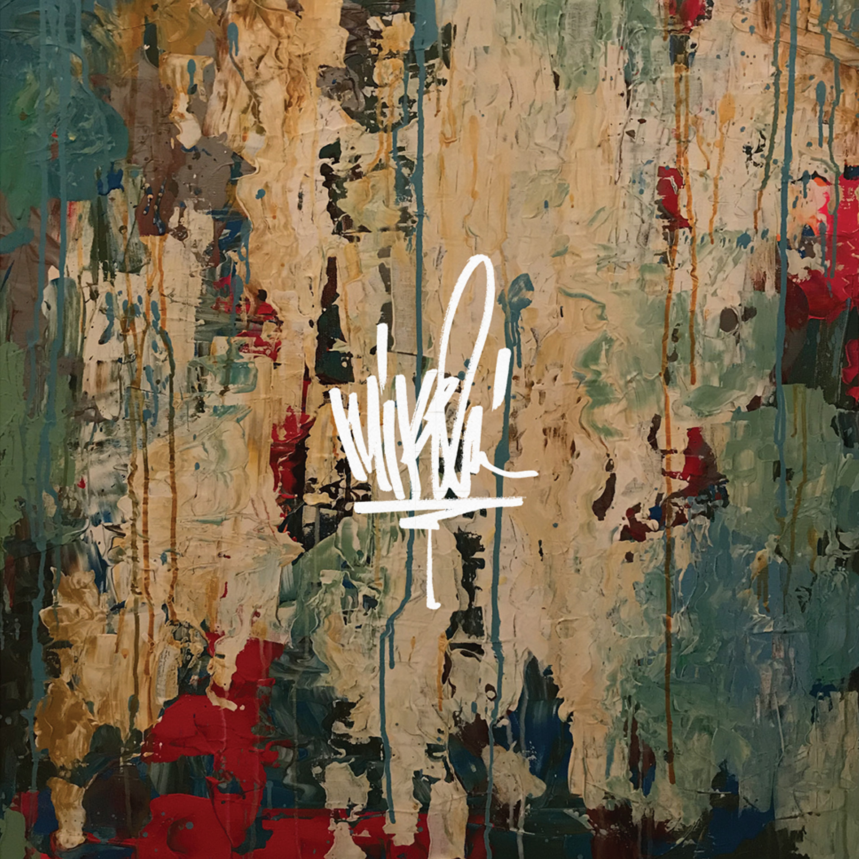
Linkin Park’s Mike Shinoda Announces Deluxe Vinyl Re-Issue of Post Traumatic with Bonus Tracks

Pre-Order Here
LOS ANGELES --- Grammy® Award-winning musician and artist Mike Shinoda announces the deluxe vinyl re-issue of his solo album, Post Traumatic.
Post Traumatic is the deeply personal solo album from Linkin Park’s Mike Shinoda recorded in the months following the passing of Linkin Park vocalist Chester Bennington.

Originally released in June 2018, the 16-track album included the 3 songs from the Post Traumatic EP released earlier that year, plus the singles “Crossing A Line” and “Make It Up As I Go”. This 18-track deluxe vinyl re-issue of Post Traumatic includes two bonus songs: “Prove You Wrong” and “What The Words Meant,”; tracks that were originally released as a limited edition 10” single and added to the digital album.

Despite its title, Post Traumatic – which includes collaborations with K.Flay, blackbear, Machine Gun Kelly, Deftones' Chino Moreno, and grandson – is an album about healing. The songs are specific about Shinoda’s experience with loss yet manage to be universally relatable, thanks to their honesty and heart.

The deluxe vinyl 2-LP set will be released on June 14th in three formats. In addition to black vinyl, two limited editions are being released: one pressed on Orange Crush vinyl, the other a Zoetrope picture disc. Pre-order HERE.
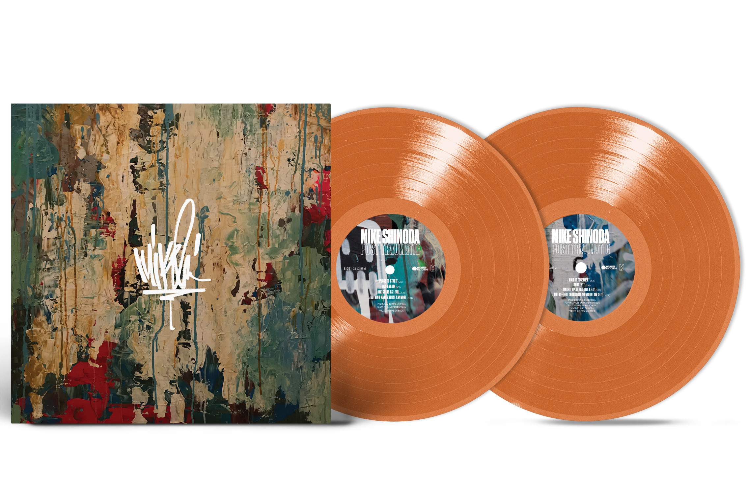
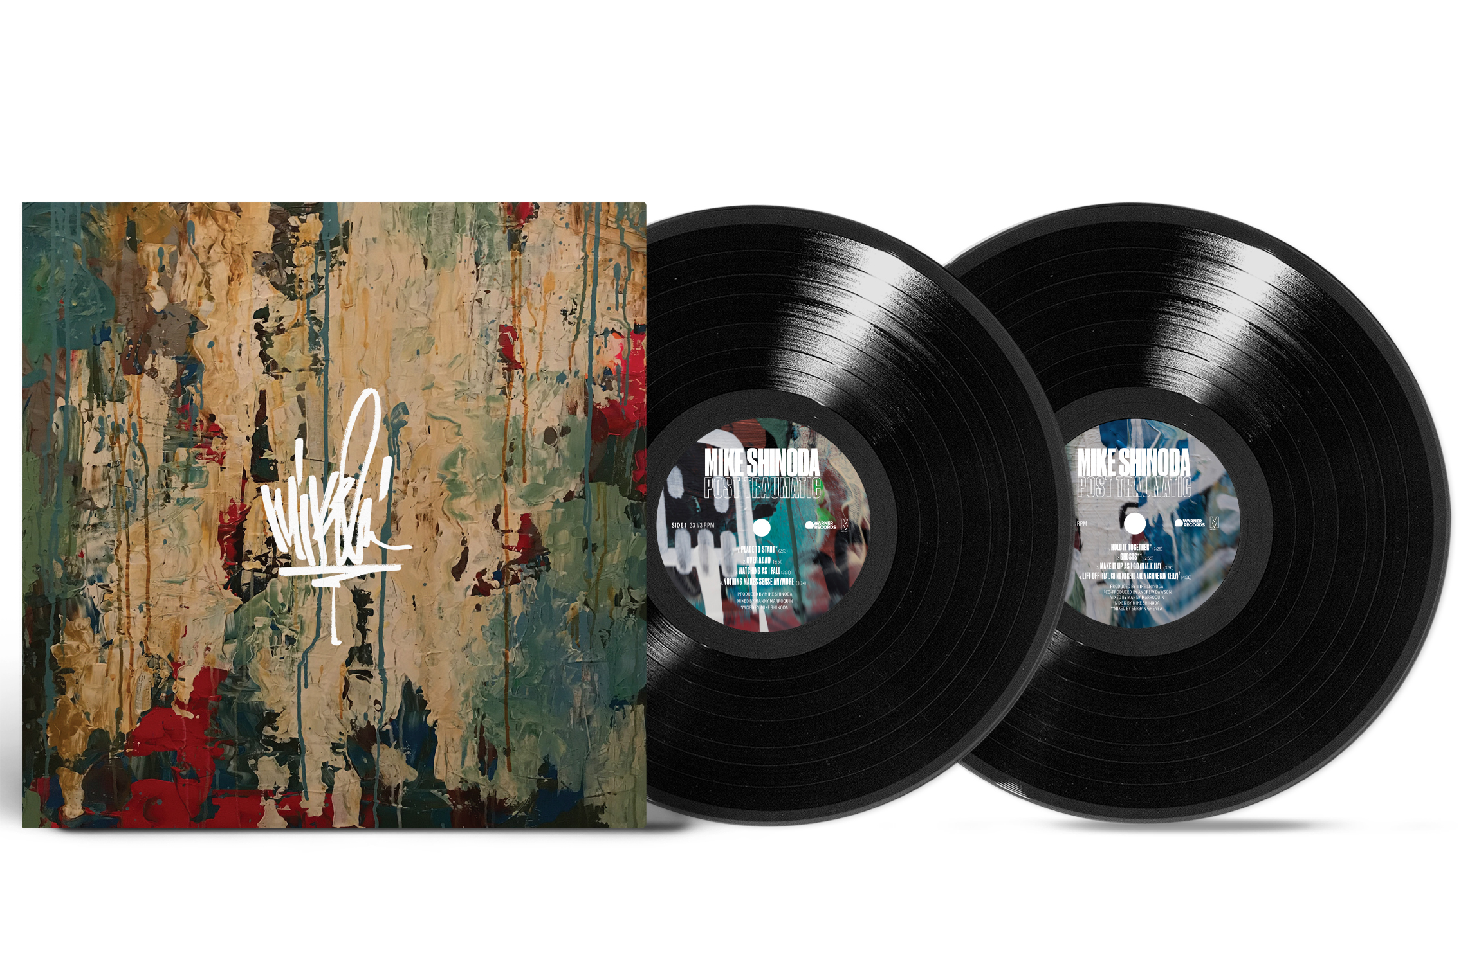

Post Traumatic (Deluxe Edition)

Tracklist

Side 1
- Place To Start
- Over Again
- Watching As I Fall
- Nothing Makes Sense Anymore
Side 2
- About You (feat. blackbear)
- Brooding (Instrumental)
- Promises I Can’t Keep
- Crossing A Line

Side 3
- Hold It Together
- Ghosts
- Make It Up As I Go (feat. K.Flay)
- Lift Off (feat. Chino Moreno and Machine Gun Kelly)
Side 4
- I.O.U.
- Running From My Shadow (feat. grandson)
- World’s On Fire
- Can’t Hear You Now
- Prove You Wrong
- What The Words Meant

